Palestinian Central Bureau of Statistics (PCBS)

International Women's Day

Palestinian Central Bureau of Statistics (PCBS), issued a press release on the International Women’s Day on Tuesday, 08/03/2016

Women constitute half of the population
The estimated population of Palestine the end of 2015 was 4.75 million, of whom 2.41 million were males and 2.34 million were females. Males comprise 50.8 percent of the total population compared to 49.2 percent for females. In other words, a sex ratio of 103.3 (There are 103 males for each 100 females)

Both Sexes | Females | Males | Region
4,749,486 | 2,336,086 | 2,413,400 | Palestine
2,898,927 | 1,425,886 | 1,473,041 | West Bank
1,850,559 | 910,200 | 940,359 | Gaza Strip

More than half of women aged 15 years and above are married
56.1 percent of total females aged 15 years and above were married, 33.8 percent had never been married. Additionally, 5.8 percent were widowed, 1.7 percent divorced, 2.5 percent engaged for the first time, and 0.1 percent were separated.

About fifth of married women aged 20-24 years gave birth before the age of 18
22.0% of the women aged 20-24 years gave birth before the age of 18, this percentage is higher in Gaza Strip compared to the West Bank (25.1 percent and 19.6 percent respectively). This percentage is three times higher for women with basic education level in comparison to those with higher education.

A continued rise in literacy among women
Despite the rise in literacy rates among females over the last decade, the gap is still in favor of males by 3.6 percent, The literacy rates reached 94.9 percent for females compared to 98.5 percent for males in 2015.

Literacy rates for men and women aged 15 years and above during 2001-2015

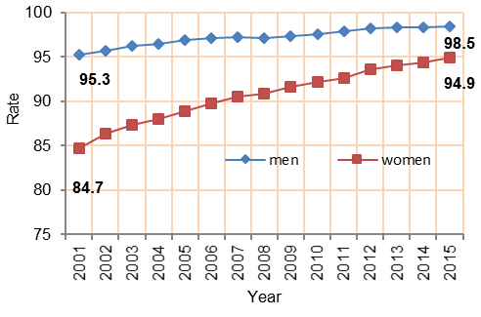

A gap in the participation rate and average daily wages between men and women

The female participation rate in the labor force was 19.1 percent in 2015 compared with 10.3 percent in 2001. The male participation rate in the labor force was more than three times higher, 71.9 percent higher than that of females.

There was a gender gap in the average daily wages: the average daily wage for females was NIS 81.9 compared to NIS 108.0 for males in 2015.

Men and women labor force participation rate aged 15 years and above during
2001-2015

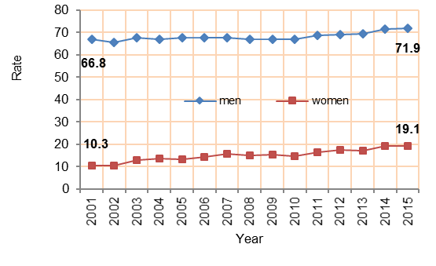

About half of women with 13 schooling years and above are unemployed
The unemployment rate was 39.2 percent for women against 22.5 percent for men in 2015. It should be noted that women unemployment rate was the highest among women with 13 years of schooling and above, standing at 48.0 percent.

Unemployment rate among men and women 15 years and above
2001-2015
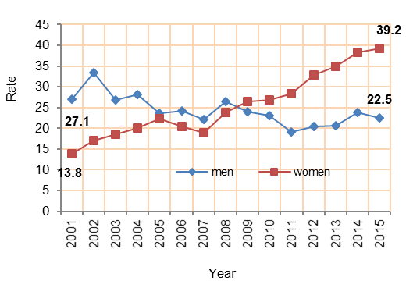

The majority of women work in the service sector (health, education and public sector)
Services and agriculture sectors comprise the main employer (job absorber) of women, accounting for 62.9 percent and 13.1 percent of the total number of employed women respectively.

Percentage distribution of employed persons

15 years and over by sex and economic activity, 2015
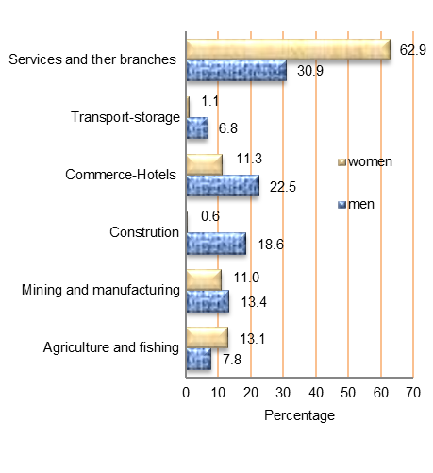

Palestinian women in public life
In 2014, 15.6 percent of judges were females whereas 84.4 percent were males and 25.0 percent of journalists were females against 75.0 percent males in Palestine. Moreover, the women ambassadors accounted for only 5.8 percent compared to 94.2 percent for males ambassadors; 41.8 percent of employees in the public sector (civil servants) were females against 58.2 percent males, 3.4 percent of women in police while 96.6 percent were male in Palestine.

