Palestinian Central Bureau of Statistics (PCBS)

On the Eve of World Elderly Day 01/10/2013

The Palestinian Central Bureau of Statistics presents this release about the situation of the elderly (60 years and over) in the occasion of the international elderly day October 1st.

Elderly People in Palestine represent 4.4% of the total population in mid 2013

Palestine witnesses improvement in life expectancy since the beginning of the last two decades. Life expectancy has increased about 5-7 years during the last two decades. In particular life expectancy increased for both males and females from 67.0 years in 1992 to 71.5years for males and 74.4 years for females in mid of the year 2013. The life expectancy is expected to increase during the coming years to reach 72.0 years for males and 75.0 years for females in the year 2015. The increase of life expectancy rate at birth resulted in the increase of the elderly number in Palestine which requires studying and researching the elderly situation in Palestine.

Unchanging percentage of the elderly in Palestine during the coming years
The Palestinian society is considered a young society where the percentage of youth is about half of the society and the percentage of the elderly is relatively small. In mid of the year 2013, the percentage of the elderly (aged 60 and over) reached 4.4% of the population in Palestine(4.8% in West Bank and 3.7% in Gaza strip). Even though, the percentage of the elderly will be increasing during the coming years in Palestine, their percentage will stay relatively low not exceeding 4.5% during the upcoming 10 years. The elderly percentage may start increasing after year 2020.

Distribution of population in Palestine by age groups, mid-2013
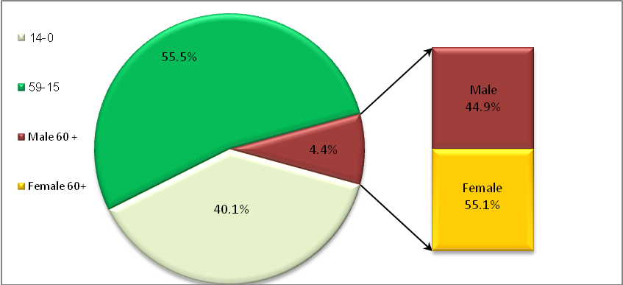

Increase of females percentage against males percentage
The percentage of males (aged 60 and over) in Palestine reached about 3.9% in 2013 against 4.9% for females (81.4 males against 100 females).

One household out of six households is headed by an elderly person
The percentage of households headed by an elderly person in the 2nd quarter of 2013 reached 15.7% in Palestine(17.1% in West Bank and 13.2% in Gaza Strip). The data indicates that the average size of the households headed by an elderly person is relatively small reached 3.5 individuals against 5.9 for the households not presided over headed by an elderly person in the 2nd quarter of 2013, (3.3 individuals for the household in West Bank and 4.1 individuals for the household in Gaza Strip).

Average of household size headed by an elderly person in Palestine by region,
the 2nd quarter of the year 2013
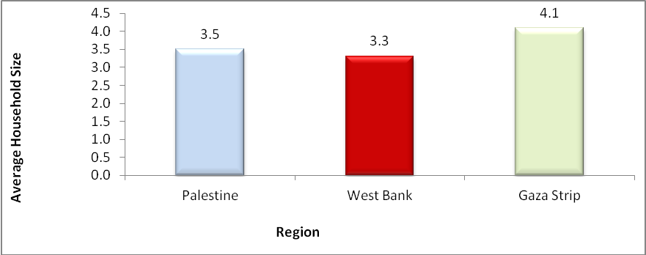

About Half of elderly females are widows
About 91.6% of the elderly males in Palestine are married against 44.4% of the elderly married females. The percentage of the elderly widowed males reached 8.3% against 48.1% for females in the 2nd quarter of the year 2013.

More than half of the working elderly are self-employed
The percentage of the elderly participation in the labor force reached about 12.5% of the total labor force in Palestine during 2nd quarter of 2013, (14.2% in West Bank and 9.0%. in Gaza strip). The percentage of the unemployed elderly in Palestine reached 3.3% (3.9% in West Bank and 1.3% in Gaza strip). The percentage of the unemployed elderly males reached 3.9%. Data also indicates that 54.1% of the working elderly are self-employed; while 18.4% are paid employees.

Distribution of labor force by region in Second Quarter 2013
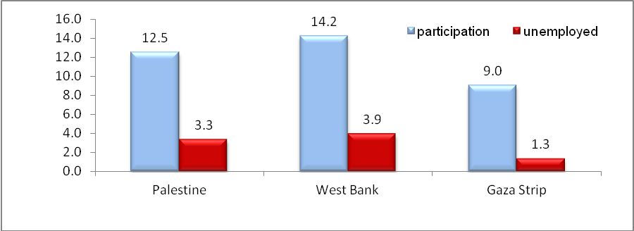

High percentage of illiterate elderly in 2012
Data indicates that there is a high percentage of illiterate elderly in 2012. The percentage of the elderly who have not completed any educational stage reached 54.8% (34.6% males and 71.1% females), and the percentage of illiteracy rate for elderly is 37.7% of the total elderly persons. They represent about 68.1% of the illiterate persons in Palestine. The percentage of the elderly who obtained diploma and higher is 10.7% in Palestine. Data on illiteracy of 2012 indicates that there is an obvious difference between males and females in receiving education where the percentage of the elderly males who have obtained a diploma and higher reached 17.7% against 5.1% for elderly females. Needless to note that the illiteracy percentage of individuals aged 15 and over does not exceed 4.1% (1.8% males against 6.4% females). The percentage of individuals (aged 15 and over) who obtained diploma and higher reached 16.9% of total population aged 15 and over in Palestine (17.4% males and 16.4% females).

Prevalence of chronic diseases among the elderly
The Palestinian Family Survey 2010 data indicates that 70.7% of the elderly aged 60 and over are infected with at least one chronic disease (71.6% in West Bank and 68.7% in Gaza strip) in Palestine. The data indicated that females are more infected with 75.4% against 64.7% males.

Percentage of the Prevalence of chronic diseases among the elderly by region, 2010
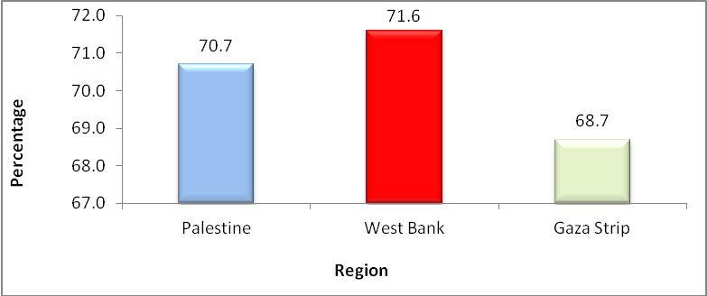

Elderly males smoke 11 times more than elderly females
2010 data indicated that 15% of the total elderly in Palestine smoke (30.9% males and 2.7% females) (18.0% in West Bank and 9.0% in Gaza Strip).

More than one-third of the elderly evaluate their health status less than good-bad
2010 data indicated that 38.4% of the elderly in Palestine evaluate their health status less than good to bad (39.7% in West Bank and 35.4% in Gaza Strip).

More than one fifth of the elderly are living in poor families in 2011
The data indicated that the percentage of the elderly living in poor families in 2011 reached 22.2% which is equivalent to 4.7% of the total number of poor people in Palestine, knowing that the percentage of the elderly does not exceed 4.4% of the total population in Palestine . The percentage of the elderly living in poor families in West Bank reached 16.5% against 35.5% in Gaza Strip.

The percentage of the elderly living in poor families by region, 2011
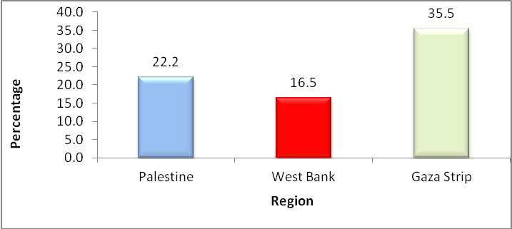
Half of the elderly do not read newspapers and magazines
2010 data indicated that 47.1% of the elderly in Palestine do not read newspapers or magazines at all (41.1% in West Bank and 60.1% in Gaza Strip). 65.4% of the elderly watch daily television and 27.8% listen daily to the radio.

