Palestinian Central Bureau of Statistics (PCBS)

Press Release on Building Licenses in Palestine, First Quarter 2013

Number of building licenses in Palestine* rose compared to previous quarter of 2012 and the first quarter of 2012

A total of 2,281 building licenses were issued in the first quarter of 2013.

The total number of building licenses issued in the first quarter of 2013 increased by 8.7% compared to the fourth quarter of 2012. Also, the total number of building licenses issued for the first quarter of 2013 was 5.0% higher than in the first quarter of 2012.

The area of licensed buildings (residential and non-residential) totaled one million m², of which new buildings made up 796 thousand m² and existing buildings 205 thousand m².

The total number of licensed dwellings was 4,200 of which 3,200 were new units with a total area of 541 thousand m² and one thousand were existing dwellings with a total area of 172 thousand m².

The number of new dwellings in the first quarter of 2013 was 13.6% lower than in the fourth quarter of 2012 and 4.3% lower than the first quarter of 2012.

Number of Building Licenses issued in Palestine*, First Quarter 2012 to First Quarter 2013

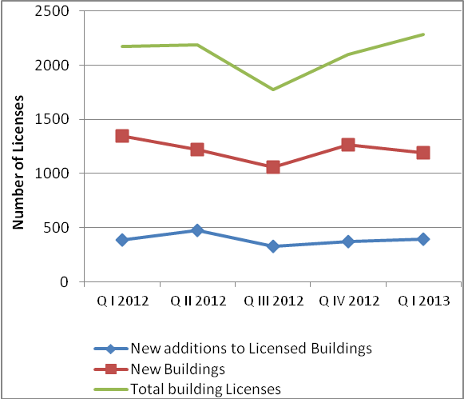
* The data exclude those parts of Jerusalem annexed by Israel in 1967.

