The Palestinian Central Bureau of Statistics (PCBS) and the Palestinian Water Authority (PWA) Issue a Press Release on the Occasion of World Water Day, March 22, 2014

Theme for World Water Day 2014 is “Water and Energy”

On the occasion of World Water Day, March 22, PCBS and PWA present key indicators related to water and energy in Palestine.

Water and energy are vitally important factors in all societies and United Nations declared “Water and Energy” as the theme for World Water Day 2014.

More than a quarter of water supplied to domestic consumers was purchased from the Israeli water company
Development in Palestinian society has led to increased demand for water and it is crucial to achieve the goals of sustainable development. Limited water resources impact on the quantity of water available, which was 349.2 million cubic meters (MCM) in 2012. Of these, 56.6 MCM were purchased from the Israeli water company “Mokrot”, constituting 28% of the water supplied to domestic consumers, in addition to iniquitous pumping from the coastal aquifer in Gaza Strip that reach to 130 MCM.

The increase in population combined with a static quantity of water defined in the Oslo Agreement has had a significant impact on the daily allocation per capita: 76.4 l/c/d in the West Bank and 89.5 l/c/d in the Gaza Strip. However, 95% of drinking water in the Gaza Strip does not meet WHO standards and is also less than the minimum quantities recommended by WHO.

The amount of water obtained from ground water aquifers is estimated to be only 15%, while 85% is drawn by Israel.

however the Palestinian also deprived from their rights in Jordan River since 1967.

About half of households consider water quality to be good
Data for 2013 revealed that 48.8% of households in Palestine considered the quality of water to be good: 73.5% in the West Bank compared to 5.8% in the Gaza Strip.

The low percentage in the Gaza Strip is due to increased salinity in the water because of the seepage of wastewater into the groundwater and the absence of supervision of drinking water by districts in the Gaza Strip.

Quarter of Palestinian households have regular water supply daily
In 2013 27% of households in Palestine had water supplied on a daily basis, while 51.3% of households were supplied with water three to four days per week.

Most energy consumed is imported from Israel
Israel is the main source of electricity in Palestine: 4,702 GWh were purchased from Israel in 2012 constituting 88.7% of the total energy purchased in Palestine of 5,301 GWh in 2012.

Around 7.4% of energy was purchased from the Palestinian company in the Gaza Strip, 2.3% of energy was imported from Egypt and 1.6% of all energy was imported from Jordan.

Palestine imports its oil fuels entirely from Israel and that the reason why Palestine has extremely high prices of fuel and energy.

About two thirds of Palestinian households rely on solar water heating
The results of the domestic energy survey (July 2013) showed that 62% of households in Palestine use solar water heating and thus save more than 600 GWh, which is estimated to be the equivalent of 100 million dollars yearly according to the Palestinian Energy Authority, placing Palestine at the top of the countries that use this renewable source of energy.

There has been a noticeable decrease in the percentage of households that use solar heating in Palestine from 72% in 2001 to 62% in 2013; around 32% of households rely on electricity as the main source to heat water according to energy data for 2013.

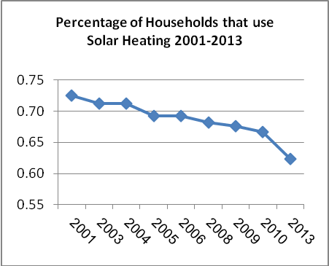

Prospects for development of water and energy
Water losses totaling 77.3 MCM in 2012 are the main problem faced by the water sector and greater efforts are required from the Palestinian government to repair the leakage of water from the water network and reduce the quantity of water losses.

Palestinian governorate should look for alternative sources of water to reduce the burden on existing domestic water sources. These might comprise the use of treated water for irrigation (111.5 MCM for agricultural use) or for cooling processes as required by power plants.

However, water treatment plants consume large amounts of energy and as most energy in Palestine is imported from Israel at a high price, this may only serve to exacerbate the problem.

Palestinian governorate needs to rely on renewable energy sources such as wind and solar energy that do not require water. For example, a desalination plant in the Gaza Strip that produces 38 MCM of fresh water would need 35 MWh. This would be lower than the 85 MWh energy required in the Gaza Strip by 2018, in addition to implement the strategic treated plant that will produce 55 MCM of fresh water.

