The Palestinian Central Bureau of Statistics (PCBS) and the Palestinian Water Authority (PWA) Issue a Press Release on the Occasion of World Water Day, March 22, 2015

Theme for World Water Day 2015 is "Water and Sustainable Development"

On the occasion of World Water Day, March 22, PCBS and PWA underscored the importance of water availability in achieving sustainable development.

The sustainable development related to water is depending on measuring the indicators associated with water quality, and available quantity of surface and ground water.

Water lies in the heart of achieving sustainable development since it is vital for the agricultural sector and the economic development of a country not to mention its impact on people’s health.

Water and Agricultural Development

Agriculture is a prime sector in developing countries since it is the main source of nutrition of the population at large and the source of income for the rural population.

Agriculture helps achieve nutrition safety and reduce poverty in order to get the agricultural development.

Due to UN data, 90% of the extracted water is used for irrigation, however the agriculture consumed 70% of the available water around the world. The quantity of water available for agriculture in Palestine is in sufficient to serve the planted areas (1,034,901 dunum) in 2010/2011, of which 167,671 dunuma of are irrigated areas.

The pumped water from agricultural wells was 114.5 MCM in 2011 and this quantity increased to reach to 123.8 MCM in 2013.

Around Half the Household Considered the Water Quality to Be Good

Regarding water quality, 48.8 % of Palestinian households considered water quality to be good in 2013.

However, responses varied with 73.5% being satisfied with the quality of water in the West Bank compared to 5.8% in the Gaza Strip. Indeed, water in Gaza is saline due to the seepage of wastewater into the aquifers not to mention the absence of any monitoring system by the local authorities in Gaza.

Israel Control the Ground Water (Aquifers)

Palestine suffers from the unfair distribution of water sources, which remain under almost full Israeli control. As an evidence to this inequality, the Israeli daily share per capita of water consumption reached seven times higher than the Palestinian’s.

The amount of water extracted from the coastal aquifer was 100.8 MCM in the Gaza Strip in 2013, but this quantity is obtained via unsafe pumping that jeopardizes sustainability of the source knowing that the basin sustainable yield should not exceed 50-60 MCM a year. More than 90% of the water pumped from the coastal aquifer in Gaza Strip does not satisfy the water quality standards of the World Health Organization.

On the other hand, the quantity of water extracted from aquifers in the West Bank in 2013 was (52.9 MCM from Eastern aquifer, 29.3 MCM from Western aquifer and 21.6 MCM from the North-Eastern aquifer).

Most of Available Water is Ground Water

Data show the percentage of the exploitation of surface and ground water from available water in the period 2009-2013 was high, with averaging about 82%.

It should be noted that the Palestinians have been denied access to extraction from the Jordan River since 1967, which deprives them of their rights to this water whose quantity was estimated at 250 MCM.

Percentage of abstracted surface and ground water from available water, 2009-2013
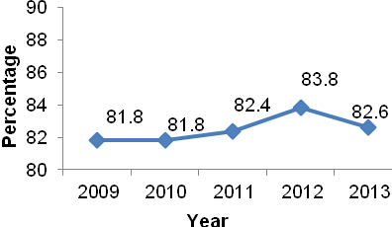

High Proportion of Households Capable to Access to Improved Water and Sanitation

Water is essential for health; this means that it is important to increase the proportion of households with access to improved water and sanitation services. Indeed, this is deemed as an environmental development in Palestine taking into account the scarcity of water and lack of access to full water rights.

In 2011, about 6.2% of households had no access to improved drinking water, but this percent dropped to 2.5% in 2013.

Percentage of households capable to access to improved water in Palestine 2009-2013
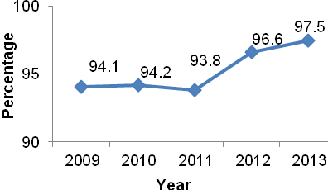

In terms of sanitation, the Israeli occupation obstructs any Palestinian construction of wastewater treatment plant, denying them thus the right to benefiting from the treated water.
In Palestine, the percentage of households with access to improved sanitation was 63.6% in 2013 compared with 51.4% in 2008.

