Palestinian Central Bureau of Statistics, in collaboration with
the Ministry of Tourism and Antiquities

Around 2.65 Million Visits to Tourist Sites in the West Bank in the First Half of 2015

On World Tourism Day on September 27, the Palestinian Central Bureau of Statistics, in collaboration with the Ministry of Tourism and Antiquities, presents the following facts on tourism in Palestine.

During the first half of 2015, around 2.65 million visits were made to tourist and leisure sites in the West Bank. These included one million visits by inbound visitors and 1.65 million visits by domestic visitors. The number of inbound and domestic visits decreased by 32% and 2% respectively compared to the same period in 2014.
Most inbound visits were to Bethlehem Governorate with 40%, followed by Jericho and Al-Aghwar Governorate with 29%, and Jenin and Hebron Governorates with 12% each.

Number of Inbound Visits During the First Half of Years (2008-2015)
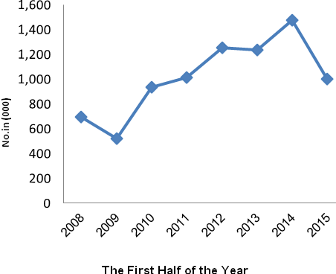

More than a third of Inbound Visits by Residents from 1948 Occupied Palestine

Palestinians residing in areas occupied in 1948 accounted for the largest proportion of inbound visitors with 38%, followed by 17% from Russia, 5% from the United States, 4% from Poland and 3% from Indonesia.

It should be noted that inbound and domestic visitor data do not include Jerusalem Governorate and Gaza Strip.

242 Thousand Hotel Guests Spent 710 Thousand Nights during the First Half of 2015 in the West Bank Hotels
The number of hotel guests in the West Bank reached 242,484 hotel guests spending 709,764 nights in the first half of 2015, showing a decrease of 32% compared to the first half of 2014.

Number of Guests by Nationality During First Half of 2014 and 2015

Nationality | 2014 | 2015
Palestine | 28,063 | 25,955
Israel | 28,286 | 30,903
Asia | 36,983 | 34,211
USA & Canada | 35,680 | 21,276
European Union | 126,157 | 76,340
Other EU Count. | 74,696 | 32,769
Other Countries | 26,724 | 21,030
Total | 356,589 | 242,484

Guests were distributed by region as follows: 52% in the south of the West Bank, 27% in Jerusalem hotels, 14% in the middle of the West Bank (Ramallah and Al-Bireh, Jericho and Al-Aghwar), and 7% in the north of the West Bank.

In June 2015, there were 110 hotels in the West Bank comprising 6,826 available rooms with 15,211 beds.
Average Spending of USD 61 on Domestic Trips and USD 1,225 on Outbound Trips in 2014
In Palestine, 37% of households (at least one household member) participated in a domestic trip during 2014: 33% in the West Bank compared to 46% in the Gaza Strip. The average household expenditure during domestic trips was USD 61: USD 87 in the West Bank compared to USD 27 in Gaza Strip. Trips abroad were conducted by 16% of households (one member at least) during 2014: 22% of West Bank households compared to only 6% of households in Gaza Strip. Average household expenditure during an outbound trip was USD 1,225, of which USD 314 was spent on shopping, USD 213 was spent on transportation, and USD 177 was spent on tourism services.

Around 7,639 Establishments Operating in the Tourism Sector in Palestine in 2013
There were 7,639 establishments working in the tourism sector in Palestine in 2013. The main operations included: 3,966 restaurants; 915 shops selling souvenirs and handicrafts; 861 outlets in beverage serving; 310 working in antiques and wooden handcrafts; 277 car rental services; 196 providing services organizing trips to Haj and Umrah; 119 in short-term accommodation (hotels) 76 travel and tourism agencies; and a further 919 establishments engaged in related tourism activities, including: creative arts and entertainment activities, and other recreational activities.

Total Output of Tourism Activities in 2013 was USD 446.7 Million
The total output of establishments working in tourism activities in 2013 was USD 446.7 million. This was made up of 45% by restaurants, 22% by accommodation activities, 10% of beverage serving activities, 5% for other amusement and recreation activities, 5% from renting and operational leasing of passenger cars (without drivers), 4% for retail sale of souvenirs, craftwork and religious articles, and 9% distributed on the remaining tourism activities.

