Palestinian Central Bureau of Statistics (PCBS)

Press Release on Israeli Settlements in Palestine, 2013

About 600 thousands Settlers in the West Bank, half of them in Jerusalem Governorate

There were 148 settlements in the West Bank at the end of 2013. 26 settlements of them were in Jerusalem governorate distributed by 16 settlements in Jerusalem (J1), and 10 settlements in Jerusalem (J2).

Number of Israeli Settlements in the West Bank by Governorate, 2013
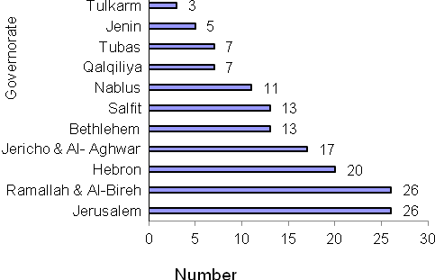

Data indicate that the number of settlers in the West Bank at the end of 2013 was 580,801.

Number of Settlers in the West Bank Settlements by Year and Region

Year | Region
Year | West Bank * | Jerusalem (J1) | West Bank
2008 | 297,933(R) | 197,071 | 495,004(R)
2009 | 313,019(R) | 192,768 | 505,787(R)
2010 | 327,642(R) | 196,178 | 523,820(R)
2011 | 342,177(R) | 199,647 | 541,824(R)
2012 | 358,364(R) | 203,176 | 561,540(R)
2013 | 374,096 | 206,705 | 580,801
R: revised data

Most settlers (281,684) are concentrated in the Jerusalem governorate, constituting 48.5% of all settlers in the West Bank. Of these, 206,705 settlers are in the Jerusalem (J1) area (those parts of Jerusalem annexed by Israel in 1967). Other settlers are in Ramallah & Al-Bireh governorate (113,253 settlers), Bethlehem governorate (69,394 settlers), then Salfit governorate (36,195 settlers). The governorate with the lowest number of settlers was Tubas with 1,909 settlers.

Number of Israeli Settlers in the West Bank by Governorate, 2013
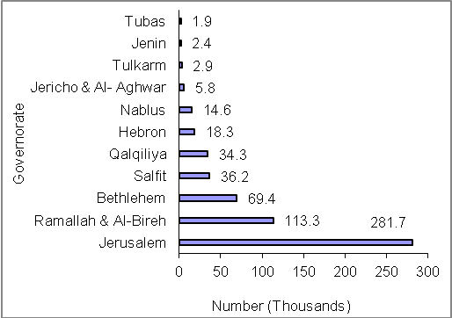

Those parts of Jerusalem, which were annexed by Israel in 1967.

