The State of Palestine, represented by the Palestinian Central Bureau of Statistics, ranks 1st in the Middle East and North Africa region in the Statistical Performance Index (SPI), as part of the World Bank's Assessment of National Statistical Systems for 2022

Ramallah - 21/01/2024 - The State of Palestine, represented by the Palestinian Central Bureau of Statistics (PCBS), has achieved the first rank in the Middle East and North Africa region in the Statistical Performance Index (SPI). This achievement comes within the framework of the World Bank's Assessment of National Statistical Systems for 2022. Palestine attained a score of 83.4% in the overall index, which comprises five key pillars within 22 dimensions.

Data Use: Through producing and providing data that are used widely and frequently by the National Statistical System, Palestine achieved a 100% rating in this pillar.
Data Services: By connecting data users with producers and facilitating dialogue between them, Palestine obtained a rating of 92.1% in this pillar.
Data Products: Reflecting the ability of countries to produce indicators related to the 17 Sustainable Development Goals, Palestine obtained a rating of 73.1% in this pillar.
Data Sources: By surpassing traditional sources as censuses and surveys to include administrative and spatial geographic data, in addition to data produced by private companies and citizens, Palestine achieved a rating of 66.7% in this pillar.
Data Infrastructure: Through well-developed hard infrastructure (legislation, governance, and standards) and soft infrastructure (skills and partnerships) as well as the financial resources to deliver useful—and widely used—data products and services, Palestine obtained a rating of 85.0% in this pillar.
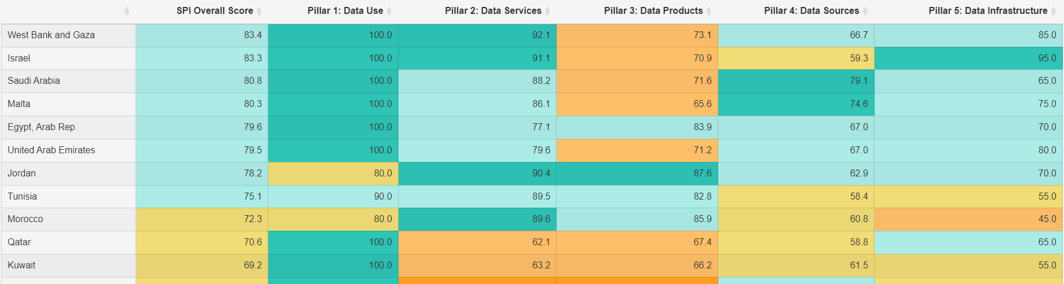
Statistical Performance Index, 2022 – Comparison of Palestine with the Top Countries in the Middle East and North Africa Region

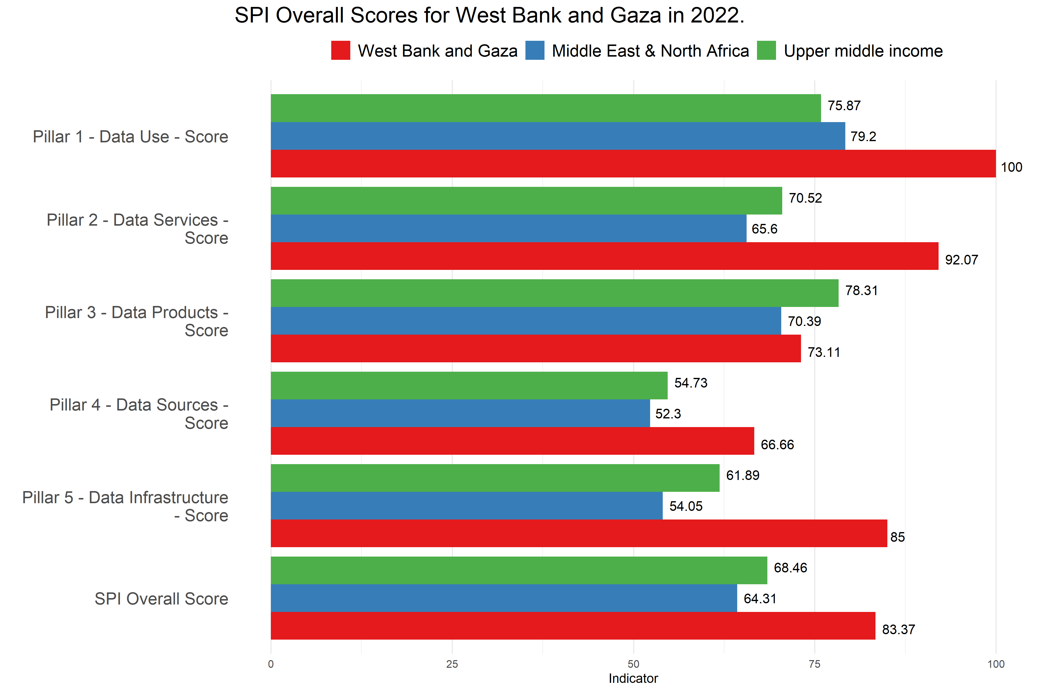
Statistical Performance Index, 2022 – Comparison of Palestine with the Average Rating of the Middle East and North Africa Region and the Upper Middle-Income Countries.

