Palestinian Central Bureau of Statistics (PCBS)

Palestinian Registered* External Trade in Goods of May, 05/2013.

Exports:
Exports decreased in May, 2013 by 3.2% compared to April, 2013 and increased by 11.6% compared to May, 2012 and reached USD 71.8 Million.

Exports to Israel decreased in May, 2013 by 0.8% compared to April, 2013 and represented 91.5% of total exports in May, 2013.

On the other hand exports to other countries decreased by 22.9% during the same period compared to April, 2013.

Imports:
Imports decreased in May, 2013 by 1.6% compared to April, 2013. And increased by 2.7% compared to May, 2012 and reached USD 396.2 Million.

Imports from Israel increased by 0.5% in May, 2013 compared to April, 2013 and represented 65.2% of total imports in May, 2013.

On the other hand, imports from other countries decreased by 5.3% compared to April, 2013.

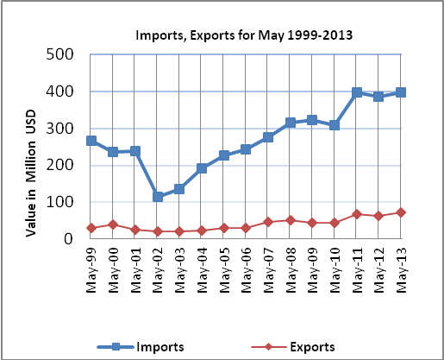

Net Trade Balance on Registered Goods:
The trade balance which represents the difference between exports and imports showed a decrease in trade deficit by 1.2% compared to April, 2013. And increased by 0.9% compared to May, 2012 and reached USD 324.4 Million.

*: Includes actual data received from official sources

