Palestinian Central Bureau of Statistics (PCBS)

Preliminary Results of the Palestinian Registered* External Trade in Goods of
August, 08/2014.

Exports
Exports increased in August, 2014 by 30.7% compared to July, 2014. It also increased by 18.7% compared to August, 2013 and reached USD 70.6 Million.

Exports to Israel increased in August, 2014 by 44.4% compared to July, 2014 and represented 90.4% of total exports in August, 2014.

On the other hand, exports to other countries decreased by 31.3% during the same period compared to July, 2014.

Imports
Imports increased in August 2014 by 6.3% compared to July, 2014. It also increased by 6.6% compared to August, 2013 and reached USD 407.2 Million.

Imports from Israel increased by 10.4% in August 2014 compared to July, 2014 and represented 63.6% of total imports in August 2014.

On the other hand, imports from other countries decreased slightly by 0.1% compared to July, 2014.

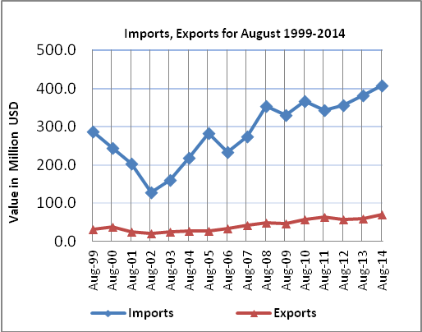

Net Trade Balance on Registered Goods
The trade balance which represents the difference between exports and imports showed an increase in trade deficit by 2.3% compared to July, 2014. It also increased by 4.4% compared to August 2013 and reached USD 336.6 Million.

*: Includes actual data received from official sources

