Palestinian Central Bureau of Statistics (PCBS)

Palestinian Registered* External Trade in Goods of July, 2012.

Exports:
Exports increased in July, 2012 by 2.3 percent compared to June, 2012 and increased by 14.3 percent compared to July, 2011 and reached USD 61.6 Million.

Exports to Israel increased in July, 2012 by 1.0 percent compared to June, 2012.

Also, exports to other countries increased by 13.5 percent during the same period compared to June, 2012.

Exports to Israel represented 89.1 percent of total exports in July, 2012.

Imports:
Imports increased in July, 2012 by 3.3 percent compared to June, 2012. And increased by 6.6 percent compared to July, 2011 and reached USD 367.5 Million.

Imports from Israel increased by 3.5 percent in July, 2012 compared to June, 2012.

Imports from Israel represented 64.9 percent of total imports in July, 2012.

On the other hand, imports from other countries increased by 2.9 percent compared to June, 2012.

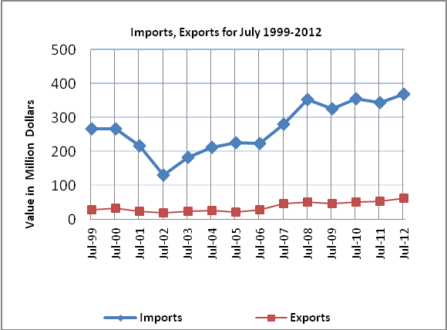

Net Trade Balance on Registered Goods:
The trade balance which represents the difference between exports and imports showed an increase in trade deficit by 3.5 percent compared to June, 2012. And increased by 5.2 percent compared to June, 2011 and reached USD 305.9 Million.

*: Includes actual data received from official sources

