Palestinian Central Bureau of Statistics (PCBS)

Preliminary Results of the Palestinian Registered* External Trade in Goods of January, 01/2014.

Exports:
Exports decreased in January, 2014 by 8.7% compared to December, 2013 while it increased by 10.1% compared to January, 2013 and reached USD 68.6 Million.

Exports to Israel decreased in January, 2014 by 4.2% compared to December, 2013 and represented 90.2% of total exports in January, 2014.

On the other hand, exports to other countries decreased by 36.2% during the same period compared to December, 2013.

Imports:
Imports increased in January 2014 by 7.9% compared to December, 2013. And increased by 15.3% compared to January, 2013 and reached USD 419.3 Million.

Imports from Israel increased by 17.2% in January 2014 compared to December, 2013 and represented 69.8% of total imports in January 2014.

On the other hand, imports from other countries decreased by 8.8% compared to December, 2013.

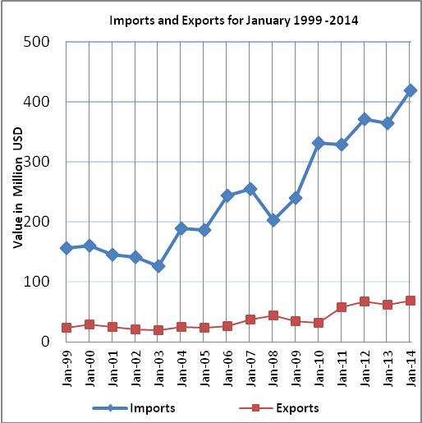

Net Trade Balance on Registered Goods:
The trade balance which represents the difference between exports and imports showed an increase in trade deficit by 11.9% compared to December, 2013. And increased by 16.4% compared to January 2013 and reached USD 350.7 Million.

*: Includes actual data received from official sources

