Palestinian Central Bureau of Statistics (PCBS)

Main results of the Palestinian Registered* External Trade in Goods and Services for 2012

Imports and Exports of Goods
The total value of imports of goods in 2012 was USD 4,697.4 Million, an increase of 7.4 percent compared to 2011. Exports of goods totaled USD 782.4 Million and increased by 4.9 percent compared to 2011. Noting that Imports and Exports of 2011 were revised to total USD 4,373.6 for Imports and USD 745.7 Million for Exports.

In 2012, the deficit in the net trade balance in goods increased by 7.9 percent compared to 2011 and totaled to USD 3,915.0 Million.

Distribution of Registered Exports and Imports by trade partners
Exports to Israel decreased in 2012 by 0.7 percent compared to 2011 and totaled USD 639.2 Million. Exports to Jordan increased by 50.4 percent and totaled USD 58.6 Million.

Exports to the European countries decreased by 0.5 percent compared to 2011 and totaled USD 14.4 Million.

Imports from Israel was increased in 2012 by 8.4 percent compared to 2011 and totaled USD 3,351.2 Million. Imports from Jordan increased by 9.4 percent during the same period compared to 2011 and totaled to USD 98.4 Million.

Imports from European countries also increased by 5.7 percent in 2012 compared to 2011 and totaled USD 469.1 Million.

Registered Imports, Exports, net Trade Balance in Goods in Palestine, 2000 - 2012
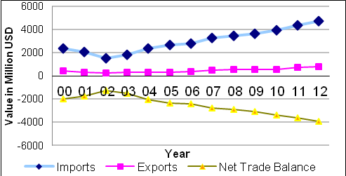

Import and export in services with Israel

The total value of imports of services from Israel in 2012 was USD 118.9 Million and decreased by 6.0 percent compared to 2011.

Exports of services to Israel decreased by 0.8 percent in 2012 compared to 2011 and reached USD 157.8 Million.

Registered Imports, Exports, Net Trade Balance in Services with Israel in Palestine
2000 – 2012
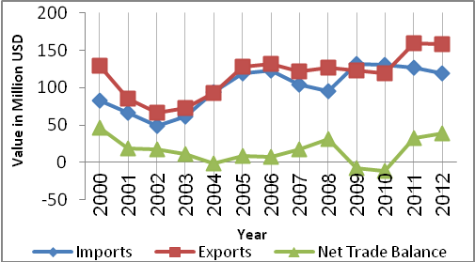

*: Includes actual data received from official sources

