Palestinian Central Bureau of Statistics (PCBS)

Preliminary Results of the Palestinian Registered* External Trade in Goods of December, 12/2015.

Exports:
Exports decreased in December, 2015 by 4.6% compared to November, 2015. It also decreased by 3.4% compared to December, 2014 and reached USD 77.6 Million.

Exports to Israel increased in December, 2015 by 3.6% compared to November, 2015 and represented 86.0% of total exports in December, 2015.

On the other hand, exports to other countries decreased by 35.9% during the same period compared to November, 2015.

Imports:
Imports slightly increased in December, 2015 by 0.1% compared to November, 2015. It also slightly increased by 0.2% compared to December, 2014 and reached USD 416.9 Million.

Imports from Israel decreased by 1.9% in December, 2015 compared to November, 2015 and represented 53.3% of total imports in December, 2015.

On the other hand, imports from other countries increased by 2.4% compared to November, 2015.

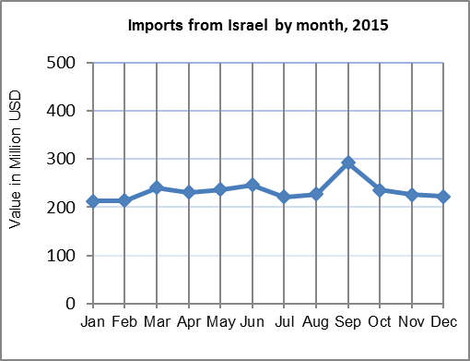

1

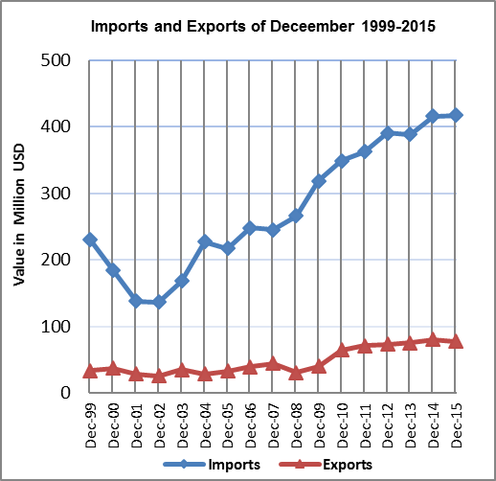

Net Trade Balance on Registered Goods:
The trade balance which represents the difference between exports and imports showed an increase in trade deficit by 1.2% in December, 2015 compared to November, 2015. It also increased by 1.0% compared to December, 2014 and reached USD 339.3 Million.

*: Includes actual data received from official sources

2

