Palestinian Central Bureau of Statistics (PCBS)

Preliminary Results of the Palestinian Registered* External Trade in Goods of
December,12/2014

Exports:
Exports increased in December, 2014 by 5.7% compared to November, 2014. It also increased by 6.8% compared to December, 2013 and reached USD 80.3 Million.

Exports to Israel increased in December, 2014 by 10.9% compared to November, 2014 and represented 85.3% of total exports in December, 2014.

On the other hand, exports to other countries decreased by 16.7% during the same period compared to November, 2014.

Imports:
Imports increased in December 2014 by 5.1% compared to November, 2014. It also increased by 7.1% compared to December, 2013 and reached USD 416.1 Million.

Imports from Israel increased by 3.2% in December 2014 compared to November, 2014 and represented 59.6% of total imports in December 2014.

On the other hand, imports from other countries increased by 7.9% compared to November, 2014.

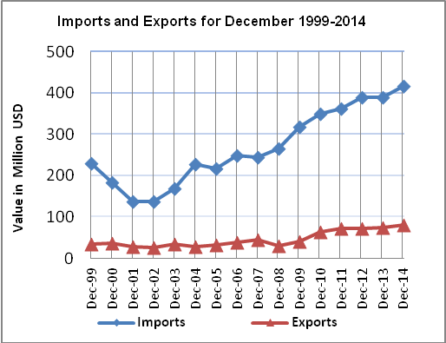

Net Trade Balance on Registered Goods:
The trade balance which represents the difference between exports and imports showed an increase in trade deficit by 4.9% in December 2014 compared to November, 2014. It also increased by 7.1% compared to December 2013 and reached USD 335.8 Million.

*: Includes actual data received from official sources

