Palestinian Central Bureau of Statistics (PCBS)

Registered* Externsl Trade In Goods Of December,12/ 2013. Palestinian

Exports:
Exports decreased in December, 2013 by 11.5% compared to November, 2013 while it increased by 2.7% compared to December, 2012 and reached USD 75.2 Million.

Exports to Israel decreased in December, 2013 by 13.5% compared to November, 2013 and represented 86.0% of total exports in December, 2013.

On the other hand exports to other countries increased by 2.8% during the same period compared to November, 2013.

Imports:
Imports increased in December 2013 by 0.1% compared to November, 2013. While it decreased by 0.5% compared to December, 2012 and reached USD 388.6 Million.

Imports from Israel increased by 0.6% in December 2013 compared to November, 2013 and represented 64.2% of total imports in December 2013.

On the other hand, imports from other countries decreased by 0.8% compared to November, 2013.

Net Trade Balance on Registered Goods:
The trade balance which represents the difference between exports and imports showed an increase in trade deficit by 3.7% compared to November, 2013. And decreased by 1.2% compared to December 2012 and reached USD 313.4 Million.

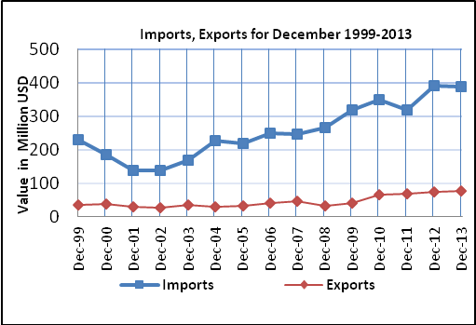

*Includes actual data received from official sources

