Palestinian Central Bureau of Statistics (PCBS)

Palestinian Registered* External Trade in Goods of October, 2012.

Exports:
Exports increased in October, 2012 by 4.4 percent compared to September, 2012 and decreased by 2.1 percent compared to October, 2011 and reached USD 61.7 Million.

Exports to Israel increased in October, 2012 by 0.2 percent compared to September, 2012.

Exports to Israel represented 85.5 percent of total exports in October, 2012.

On the other hand exports to other countries increased by 39.3 percent during the same period compared to September, 2012.

Imports:
Imports increased in October, 2012 by 8.0 percent compared to September, 2012. And increased by 8.3 percent compared to October, 2011 and reached USD 354.7 Million.

Imports from Israel decreased by 3.7 percent in October, 2012 compared to September, 2012.
Imports from Israel represented 61.4 percent of total imports in October, 2012.

On the other hand, imports from other countries increased by 34.1 percent compared to September, 2012.

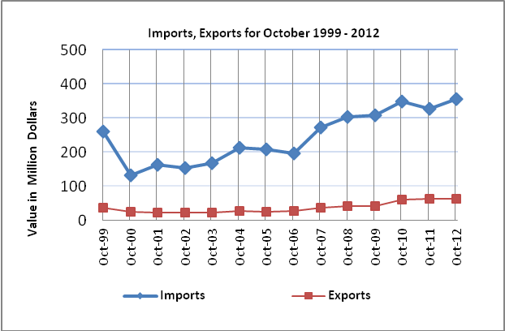

Net Trade Balance on Registered Goods:
The trade balance which represents the difference between exports and imports showed an increase in trade deficit by 8.8 percent compared to September, 2012. And increased by 10.8 percent compared to October, 2011 and reached USD 293.0 Million.

*: Includes actual data received from official sources

