Palestinian Central Bureau of Statistics (PCBS)

Preliminary Results of the Palestinian Registered* External Trade in Goods of
November,11/ 2014

Exports:
Exports slightly decreased in November, 2014 by 0.7% compared to October, 2014. It also decreased by 10.6% compared to November, 2013 and reached USD 76.0 Million.

Exports to Israel decreased in November, 2014 by 4.5% compared to October, 2014 and represented 81.3% of total exports in November, 2014.

On the other hand, exports to other countries increased by 20.4% during the same period compared to October, 2014.

Imports:
Imports slightly increased in November 2014 by 0.4% compared to October, 2014. It also increased by 2.0% compared to November, 2013 and reached USD 396.0 Million.

Imports from Israel decreased by 6.4% in November 2014 compared to October, 2014 and represented 60.6% of total imports in November 2014.

On the other hand, imports from other countries increased by 13.0% compared to October, 2014.

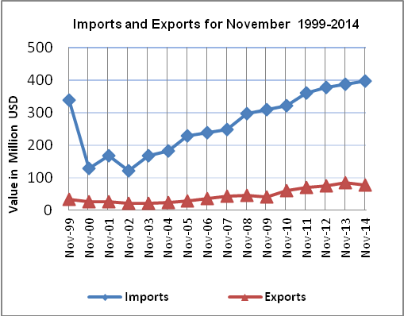

Net Trade Balance on Registered Goods:
The trade balance which represents the difference between exports and imports showed a slight increase in trade deficit by 0.6% in November 2014 compared to October, 2014. It also increased by 5.5% compared to November 2013 and reached USD 320.0 Million.

* Includes actual data received from official sources

