Palestinian Central Bureau of Statistics (PCBS)

Palestinian Registered* External Trade in Goods of November, 11/2013.

Exports
Exports increased in November, 2013 by 18.6% compared to October, 2013 and increased by 13.2% compared to November, 2012 and reached USD 85.0 Million.

Exports to Israel increased in November, 2013 by 16.6% compared to October, 2013 and represented 87.9% of total exports in November, 2013.

On the other hand exports to other countries increased by 35.8% during the same period compared to October, 2013.

Imports
Imports decreased in November 2013 by 1.7% compared to October, 2013. And increased by 2.9% compared to November, 2012 and reached USD 388.3 Million.

Imports from Israel increased by 6.1% in November 2013 compared to October, 2013 and represented 63.9% of total imports in November 2013.

On the other hand, imports from other countries decreased by 13.0% compared to October, 2013.

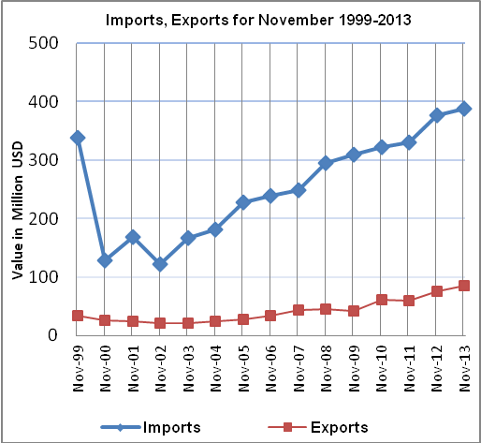

Net Trade Balance on Registered Goods
The trade balance which represents the difference between exports and imports showed a decrease in trade deficit by 6.2% compared to October, 2013. And increased by 0.3% compared to November 2012 and reached USD 303.3 Million.

*: Includes actual data received from official sources

