Palestinian Central Bureau of Statistics (PCBS)

Palestinian Registered* External Trade in Goods of November, 2012.

Exports:
Exports increased in November, 2012 by 12.5 percent compared to October, 2012 and increased by 15.9 percent compared to November, 2011 and reached USD 69.4 Million.

Imports:
Imports decreased in November, 2012 by 11.1 percent compared to October, 2012. And decreased by 4.5 percent compared to November, 2011 and reached USD 315.2 Million.

Net Trade Balance on Registered Goods:
The trade balance which represents the difference between exports and imports showed a decrease in trade deficit by 16.1 percent compared to October, 2012. And increased by 9.0 percent compared to November, 2011 and reached USD 245.8 Million.

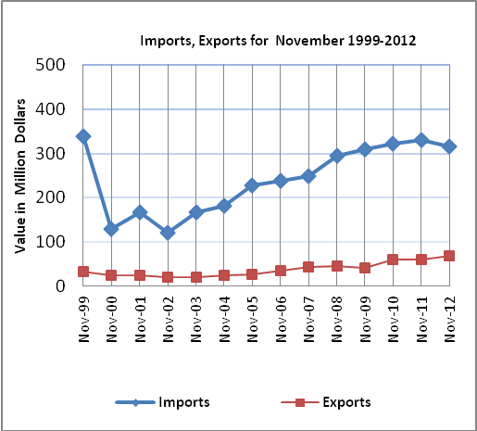

*: Includes actual data received from official sources

