Palestinian Central Bureau of Statistics (PCBS)

Preliminary Results of the Palestinian Registered* External Trade in Goods of
October, 102014/

Exports:
Exports increased in October, 2014 by 1.1% compared to September, 2014. It also increased by 6.8% compared to October, 2013 and reached USD 76.5 Million.

Exports to Israel decreased in October, 2014 by 4.6% compared to September, 2014 and represented 84.6% of total exports in October, 2014.

On the other hand, exports to other countries increased by 49.3% during the same period compared to September, 2014.

Imports:
Imports decreased in October 2014 by 6.8% compared to September, 2014. It also slightly decreased by 0.1% compared to October, 2013 and reached USD 394.5 Million.

Imports from Israel decreased by 8.9% in October 2014 compared to September, 2014 and represented 65.0% of total imports in October 2014.

On the other hand, imports from other countries decreased by 2.5% compared to September, 2014.

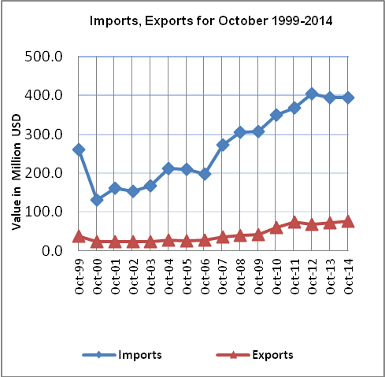

Net Trade Balance on Registered Goods:
The trade balance which represents the difference between exports and imports showed a decrease in trade deficit by 8.5% in October 2014 compared to September, 2014. It also decreased by 1.6% compared to October 2013 and reached USD 318.0 Million.

*: Includes actual data received from official sources

