Palestinian Central Bureau of Statistics (PCBS)

Palestinian Registered* External Trade in Goods of October, 2013.

Exports:
Exports increased in October, 2013 by 7.3% compared to September, 2013 and increased by 6.8% compared to October, 2012 and reached USD 71.6 Million.

Exports to Israel increased in October, 2013 by 8.2% compared to September, 2013 and represented 89.5% of total exports in October, 2013.

On the other hand no changes on exports to other countries during the same period compared to September, 2013.

Imports:
Imports increased in October 2013 by 10.2% compared to September, 2013. And decreased by 2.2% compared to October, 2012 and reached USD 394.9 Million.

Imports from Israel decreased by 8.9% in October 2013 compared to September, 2013 and represented 59.2% of total imports in October 2013.

On the other hand, imports from other countries increased by 58.5% compared to September, 2013.

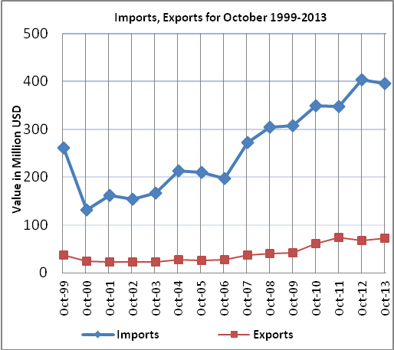

Net Trade Balance on Registered Goods:
The trade balance which represents the difference between exports and imports showed an increase in trade deficit by 10.9% compared to September, 2013. And decreased by 4.0% compared to October 2012 and reached USD 323.3 Million.

*: Includes actual data received from official sources

