Palestinian Central Bureau of Statistics (PCBS)

Palestinian Registered* External Trade in Goods of September, 2013.

Exports:
Exports increased in September, 2013 by 12.3% compared to August, 2013 and increased by 13.0% compared to September, 2012 and reached USD 66.7 Million.

Exports to Israel increased in September, 2013 by 8.7% compared to August, 2013 and represented 88.7% of total exports in September, 2013.

On the other hand exports to other countries increased by 52.6% during the same period compared to August, 2013.

Imports:
Imports decreased in September 2013 by 6.2% compared to August, 2013. And increased by 9.1% compared to September, 2012 and reached USD 358.2 Million.

Imports from Israel increased by 4.3% in September 2013 compared to August, 2013 and represented 71.6% of total imports in September 2013.

On the other hand, imports from other countries decreased by 25.3% compared to August, 2013.

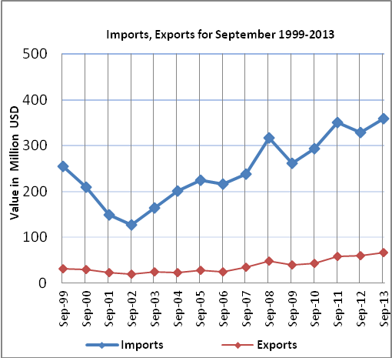

Net Trade Balance on Registered Goods:
The trade balance which represents the difference between exports and imports showed a decrease in trade deficit by 9.6% compared to August, 2013. And increased by 8.3% compared to September 2012 and reached USD 291.5 Million.

*: Includes actual data received from official sources

