Palestinian Central Bureau of Statistics (PCBS)
Preliminary Results of the Palestinian Registered* External Trade in Goods of
August,08/2015.

Exports:
Exports increased in August, 2015 by 18.8% compared to July, 2015. It also increased by 19.1% compared to August, 2014 and reached USD 84.1 Million.

Exports to Israel increased in August, 2015 by 16.8% compared to July, 2015 and represented 87.9% of total exports in August, 2015.

On the other hand, exports to other countries increased by 36.1% during the same period compared to July, 2015.

Imports:
Imports increased in August 2015 by 6.2% compared to July, 2015. It also increased by 5.3% compared to August, 2014 and reached USD 428.7 Million.

Imports from Israel increased by 2.4% in August 2015 compared to July, 2015 and represented 53.0% of total imports in August 2015.

On the other hand, imports from other countries increased by 10.9% compared to July, 2015.

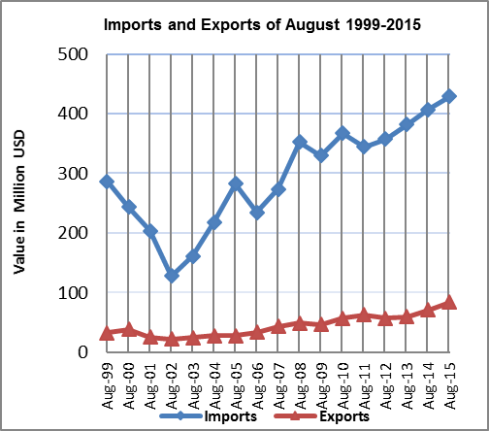

Net Trade Balance on Registered Goods:
The trade balance which represents the difference between exports and imports showed an increase in trade deficit by 3.5% in August 2015 compared to July, 2015. It also increased by 2.4% compared to August 2014 and reached USD 344.6 Million.

* Includes actual data received from official sources

