Palestinian Central Bureau of Statistics (PCBS)

Palestinian Registered* External Trade in Goods of August, 08/2013.

Exports:
Exports decreased in August, 2013 by 13.4% compared to July, 2013 and increased by 3.6% compared to August, 2012 and reached USD 59.4 Million.

Exports to Israel decreased in August, 2013 by 12.8% compared to July, 2013 and represented 91.7% of total exports in August, 2013.

On the other hand exports to other countries decreased by 19.7% during the same period compared to July, 2013.

Imports:
Imports decreased in August 2013 by 7.4% compared to July, 2013. And increased by 7.0% compared to August, 2012 and reached USD 382.0 Million.

Imports from Israel decreased by 6.8% in August 2013 compared to July, 2013 and represented 64.4% of total imports in August 2013.

On the other hand, imports from other countries decreased by 8.6% compared to July, 2013.

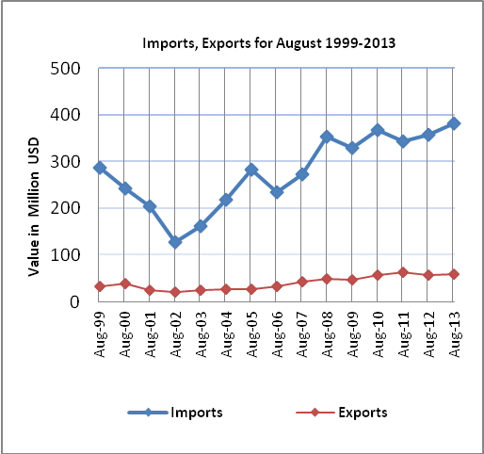

Net Trade Balance on Registered Goods:
The trade balance which represents the difference between exports and imports showed a decrease in trade deficit by 6.2% compared to July, 2013. And increased by 7.6% compared to August 2012 and reached USD 322.6 Million.

*: Includes actual data received from official sources

