Palestinian Central Bureau of Statistics (PCBS)

Preliminary Results of the Palestinian Registered* External Trade in Goods of
July, 07/2015.

Exports:
Exports decreased in July, 2015 by 17.8% compared to June, 2015. While it increased by 31.1% compared to July, 2014 and reached USD 70.8 Million.

Exports to Israel decreased in July, 2015 by 14.2% compared to June, 2015 and represented 89.4% of total exports in July, 2015.

On the other hand, exports to other countries decreased by 39.1% during the same period compared to June, 2015.

Imports:
Imports decreased in July 2015 by 9.3% compared to June, 2015. While it increased by 5.4% compared to July, 2014 and reached USD 403.6 Million.

Imports from Israel decreased by 10.0% in July 2015 compared to June, 2015 and represented 55.0% of total imports in July 2015.

On the other hand, imports from other countries decreased by 8.3% compared to June, 2015.

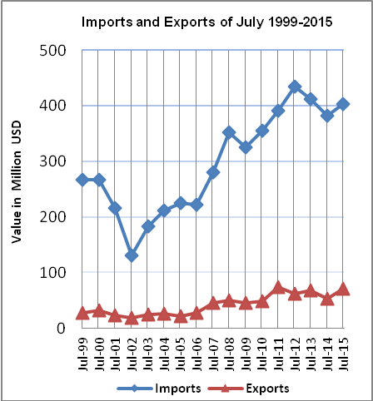
Net Trade Balance on Registered Goods:
The trade balance which represents the difference between exports and imports showed a decrease in trade deficit by 7.2% in July 2015 compared to June, 2015. While it increased by 1.2% compared to July 2014 and reached USD 332.8 Million.

*: Includes actual data received from official sources

