Palestinian Central Bureau of Statistics (PCBS)

Preliminary Results of the Palestinian Registered* External Trade in Goods of
July,07/2014.

Exports:
Exports decreased in July, 2014 by 27.5% compared to June, 2014. It also decreased by 21.3% compared to July, 2013 and reached USD 54.0 Million.

Exports to Israel decreased in July, 2014 by 31.8% compared to June, 2014 and represented 81.8% of total exports in July, 2014.

On the other hand, exports to other countries increased by 0.9% during the same period compared to June, 2014.

Imports:
Imports decreased in July 2014 by 16.7% compared to June, 2014. It also decreased by 7.2% compared to July, 2013 and reached USD 383.0 Million.

Imports from Israel decreased by 18.0% in July 2014 compared to June, 2014 and represented 61.2% of total imports in July 2014.

On the other hand, imports from other countries decreased by 14.7% compared to June, 2014.

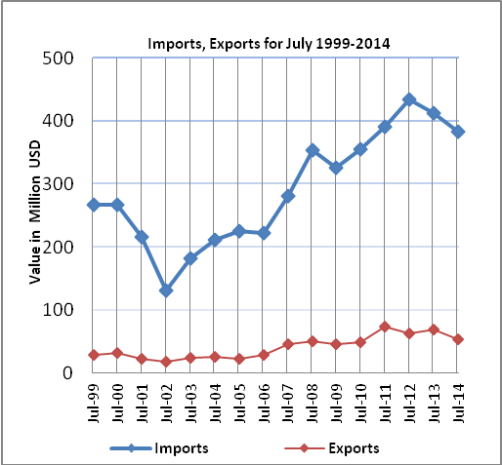

Net Trade Balance on Registered Goods:
The trade balance which represents the difference between exports and imports showed a decrease in trade deficit by 14.7% compared to June, 2014. It also decreased by 4.4% compared to July 2013 and reached USD 329.0 Million.

*: Includes actual data received from official sources

