Palestinian Central Bureau of Statistics (PCBS)

Preliminary Results of the Palestinian Registered* External Trade in Goods of
June, 06/2015.

Exports:
Exports increased in June, 2015 by 1.3% compared to May, 2015. It also increased by 15.6% compared to June, 2014 and reached USD 86.1 Million.

Exports to Israel slighty decreased in June, 2015 by 0.8% compared to May, 2015 and represented 85.7% of total exports in June, 2015.

On the other hand, exports to other countries increased by 16.2% during the same period compared to May, 2015.

Imports:
Imports increased in June 2015 by 8.2% compared to May, 2015. While it decreased by 3.3% compared to June, 2014 and reached USD 444.8 Million.

Imports from Israel increased by 4.1% in June 2015 compared to May, 2015 and represented 55.5% of total imports in June 2015.

On the other hand, imports from other countries increased by 13.7% compared to May, 2015.
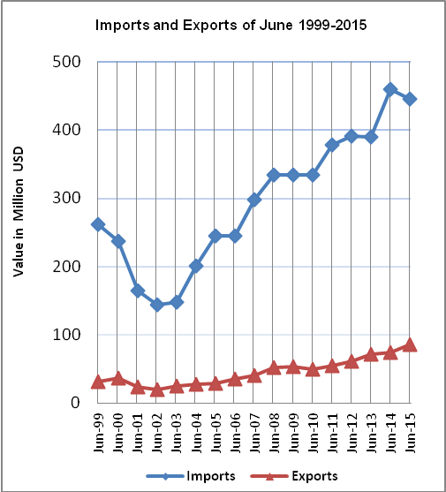

Net Trade Balance on Registered Goods:
The trade balance which represents the difference between exports and imports showed an increase in trade deficit by 10.0% in June 2015 compared to May, 2015. While it decreased by 7.0% compared to June 2014 and reached USD 358.7 Million.

*: Includes actual data received from official sources

