Palestinian Central Bureau of Statistics (PCBS)

Preliminary Results of the Palestinian Registered* External Trade in Goods of
May, 05/2014

Exports:
Exports increased in May, 2014 by 8.7% compared to April, 2014. It also increased by 6.3% compared to May, 2013 and reached USD 76.3 Million.

Exports to Israel increased in May, 2014 by 7.1% compared to April, 2014 and represented 86.5% of total exports in May, 2014.

On the other hand, exports to other countries increased by 20.4% during the same period compared to April, 2014.

Imports:
Imports decreased in May 2014 by 2.1% compared to April, 2014. While it increased by 15.9% compared to May, 2013 and reached USD 459.0 Million.

Imports from Israel decreased by 7.3% in May 2014 compared to April, 2014 and represented 65.3% of total imports in May 2014.

On the other hand, imports from other countries increased by 9.4% compared to April, 2014.
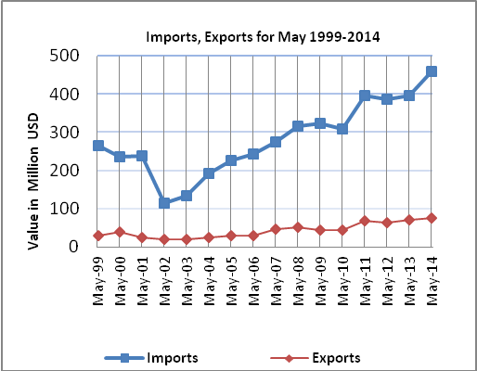

Net Trade Balance on Registered Goods:
The trade balance which represents the difference between exports and imports showed a decrease in trade deficit by 4.0% compared to April, 2014. While it increased by 18.0% compared to May 2013 and reached USD 382.7 Million.

*: Includes actual data received from official sources

