Palestinian Central Bureau of Statistics (PCBS)

Preliminary Results of the Palestinian Registered* External Trade in Goods of
April, 04/2015.

Exports:
Exports decreased in April, 2015 by 2.8% compared to March, 2015. While it increased by 8.3% compared to April, 2014 and reached USD 76.0 Million.

Exports to Israel decreased in April, 2015 by 3.9% compared to March, 2015 and represented 86.3% of total exports in April, 2015.

On the other hand, exports to other countries increased by 4.7% during the same period compared to March, 2015.

Imports:
Imports increased in April 2015 by 4.9% compared to March, 2015. While it decreased by 10.4% compared to April, 2014 and reached USD 420.0 Million.

Imports from Israel decreased by 3.8% in April 2015 compared to March, 2015 and represented 55.1% of total imports in April 2015.

On the other hand, imports from other countries increased by 18.1% compared to March, 2015.

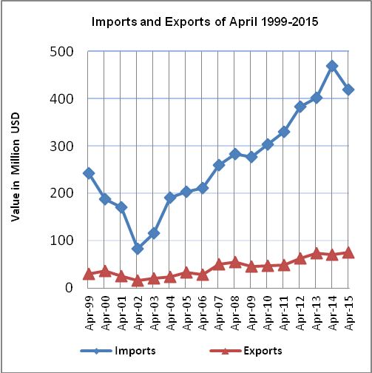
Net Trade Balance on Registered Goods:
The trade balance which represents the difference between exports and imports showed an increase in trade deficit by 6.8% in April 2015 compared to March, 2015. While it decreased by 13.7% compared to April 2014 and reached USD 344.0 Million.

*: Includes actual data received from official sources

