Palestinian Central Bureau of Statistics (PCBS)

Preliminary Results of the Palestinian Registered* External Trade in Goods of
April, 04/2014.

Exports
Exports decreased in April, 2014 by 4.2% compared to March, 2014. It also decreased by 5.4% compared to April, 2013 and reached USD 70.2 Million.

Exports to Israel decreased in April, 2014 by 3.6% compared to March, 2014 and represented 87.8% of total exports in April, 2014.

On the other hand, exports to other countries decreased by 9.0% during the same period compared to March, 2014.

Imports
Imports increased in April 2014 by 12.2% compared to March, 2014. It also increased by 16.4% compared to April, 2013 and reached USD 468.9 Million.

Imports from Israel increased by 13.0% in April 2014 compared to March, 2014 and represented 68.9% of total imports in April 2014.

On the other hand, imports from other countries increased by 10.3% compared to March, 2014.

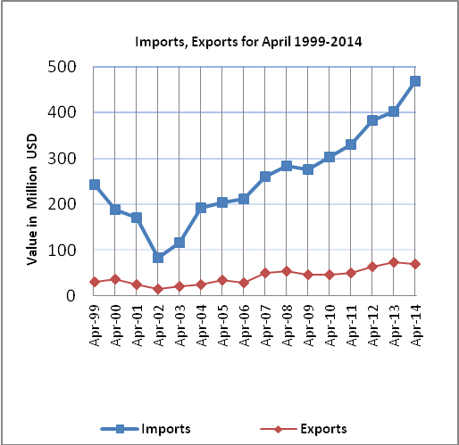

Net Trade Balance on Registered Goods
The trade balance which represents the difference between exports and imports showed an increase in trade deficit by 15.6% compared to March, 2014. And increased by 21.4% compared to April 2013 and reached USD 398.7 Million.

*: Includes actual data received from official sources

