Palestinian Central Bureau of Statistics (PCBS)

Preliminary Results of the Palestinian Registered* External Trade in Goods of February, 02/2015.

Exports:
Exports increased in February, 2015 by 4.5% compared to January, 2015. While it decreased by 1.2% compared to February, 2014 and reached USD 68.0 Million.

Exports to Israel increased in February, 2015 by 5.3% compared to January, 2015 and represented 87.6% of total exports in February, 2015.

On the other hand, exports to other countries slighty decreased by 0.2% during the same period compared to January, 2015.

Imports:
Imports decreased in February 2015 by 8.5% compared to January, 2015. It also decreased by 15.5% compared to February, 2014 and reached USD 345.8 Million.

Imports from Israel slightly increased by 0.5% in February 2015 compared to January, 2015 and represented 61.8% of total imports in February 2015.

On the other hand, imports from other countries decreased by 20.0% compared to January, 2015.

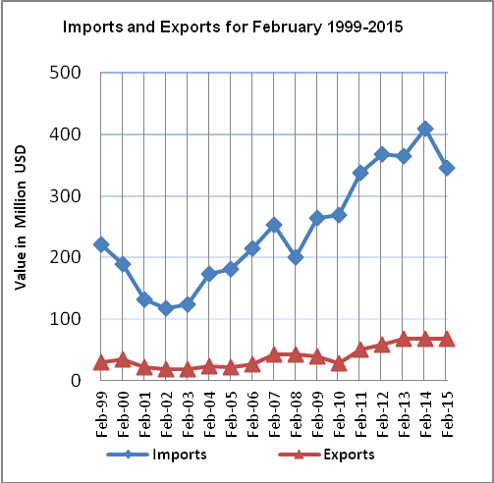

Net Trade Balance on Registered Goods:
The trade balance which represents the difference between exports and imports showed a decrease in trade deficit by 11.2% in February 2015 compared to January, 2015. It also decreased by 18.4% compared to February 2014 and reached USD 277.8 Million.

*: Includes actual data received from official sources

