Palestinian Central Bureau of Statistics (PCBS)

Palestinian Registered* External Trade in Goods of February, 2013.

Exports:
Exports increased in February, 2013 by 10.6 % compared to January, 2013 and increased by 16.5 % compared to February, 2012 and reached USD 68.9 Million.

Exports to Israel increased in February, 2013 by 7.0 % compared to January, 2013 and reached USD 61.5 Million.

Exports to Israel represented 89.3 % of total exports in February, 2013.

On the other hand exports to other countries increased by 54.2% during the same period compared to January, 2013 and reached USD 7.4 Million.

Imports:
Imports increased in February, 2013 by 0.2 % compared to January, 2013. And increased by 7.2 % compared to February, 2012 and reached USD 364.3 Million.

Imports from Israel increased by 2.4% in February, 2013 compared to January, 2013 and reached USD 253.0 Million.

Imports from Israel represented 69.4 percent of total imports in February, 2013.

On the other hand, imports from other countries decreased by 4.5%compared to January, 2013 reached USD 111.3 Million.

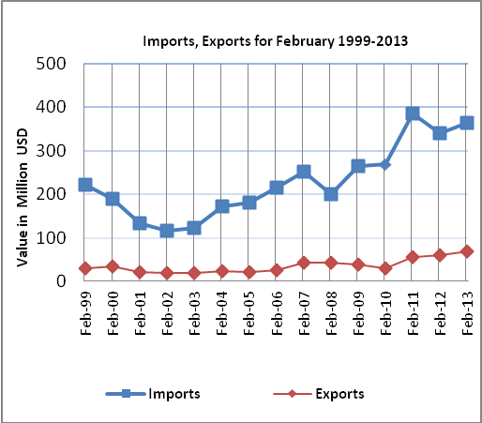

Net Trade Balance on Registered Goods:
The trade balance which represents the difference between exports and imports showed a decrease in trade deficit by 2.0% compared to January, 2013. And increased by 5.3% compared to February, 2012 and reached USD 295.4 Million.

*: Includes actual data received from official sources

