Palestinian Central Bureau of Statistics (PCBS)

Preliminary Results of the Palestinian Registered* External Trade in Goods of
January, 01/2015.

Exports:
Exports decreased in January, 2015 by 18.9% compared to December, 2014. It also decreased by 5.2% compared to January, 2014 and reached USD 65.1 Million.

Exports to Israel decreased in January, 2015 by 17.4% compared to December, 2014 and represented 87.0% of total exports in January, 2015.

On the other hand, exports to other countries decreased by 28.7% during the same period compared to December, 2014.

Imports:
Imports decreased in January 2015 by 9.2% compared to December, 2014. It also decreased by 9.9% compared to January, 2014 and reached USD 377.8 Million.

Imports from Israel decreased by 14.2% in January 2015 compared to December, 2014 and represented 56.3% of total imports in January 2015.

On the other hand, imports from other countries decreased by 1.8% compared to December, 2014.

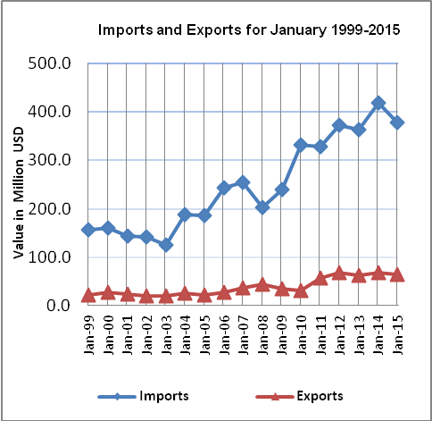

Net Trade Balance on Registered Goods:
The trade balance which represents the difference between exports and imports showed a decrease in trade deficit by 6.9% in January 2015 compared to December, 2014. It also decreased by 10.8% compared to January 2014 and reached USD 312.7 Million.

*: Includes actual data received from official sources

