Palestinian Central Bureau of Statistics (PCBS)

Palestinian Registered* External Trade in Goods of January, 2013.

Exports:
Exports showed stability in January, 2013 compared to December, 2012. and increased by 1.0 percent compared to January, 2012, and reached USD 62.3 Million.

Imports:
Imports decreased in January, 2013 by 0.8 percent compared to December, 2012. On the other hand, imports increased by 7.5 percent compared to January, 2012 and reached USD 363.6 Million.

Net Trade Balance on Registered Goods:
The trade balance which represents the difference between exports and imports showed a decrease in trade deficit by 1.0 percent compared to December, 2012. And increased by 9.0 percent compared to January, 2012 and reached USD 301.3 Million.

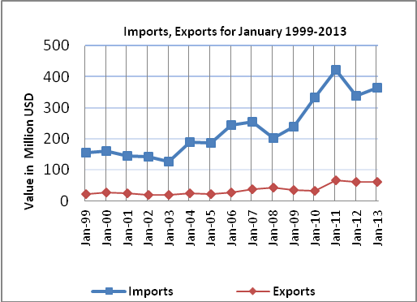

*: Includes actual data received from official sources

