Palestinian Central Bureau of Statistics (PCBS)

Palestinian Registered* External Trade in Goods of June, 06/2013.

Exports:
Exports decreased in June, 2013 by 1.0% compared to May, 2013 and increased by 18.1% compared to June, 2012 and reached USD 71.1 Million.

Exports to Israel decreased in June, 2013 by 2.9% compared to May, 2013 and represented 89.7% of total exports in June, 2013.

On the other hand exports to other countries increased by 19.3% during the same period compared to May, 2013.

Imports:
Imports decreased in June, 2013 by 1.8% compared to May, 2013. And increased by 9.3% compared to June, 2012 and reached USD 389.1 Million.

Imports from Israel decreased by 0.8% in June, 2013 compared to May, 2013 and represented 65.8% of total imports in June, 2013.

On the other hand, imports from other countries decreased by 3.6% compared to May, 2013.

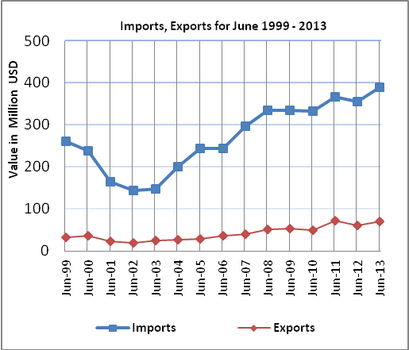

Net Trade Balance on Registered Goods:
The trade balance which represents the difference between exports and imports showed a decrease in trade deficit by 2.0% compared to May, 2013. And increased by 7.5% compared to June, 2012 and reached USD 318.0 Million.

*: Includes actual data received from official sources

