Palestinian Central Bureau of Statistics (PCBS)

Palestinian Registered* External Trade in Goods of April, 2013.

Exports:
Exports increased in April, 2013 by 14.9% compared to March, 2013 and increased by 22.3% compared to April, 2012 and reached USD 74.2 Million.

Exports to Israel increased in April, 2013 by 14.5% compared to March, 2013 and represented 89.3% of total exports in April, 2013.

On the other hand exports to other countries increased by 18.1% during the same period compared to March, 2013.

Imports:
Imports increased in April, 2013 by 18.7% compared to March, 2013. And increased by 9.6% compared to April, 2012 and reached USD 402.7 Million.

Imports from Israel increased by 9.6% in April, 2013 compared to March, 2013 and represented 63.9% of total imports in April, 2013.

On the other hand, imports from other countries increased by 39.1% compared to March, 2013.

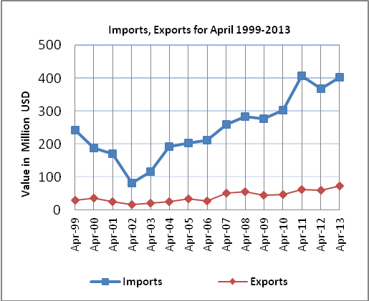

Net Trade Balance on Registered Goods:
The trade balance which represents the difference between exports and imports showed an increase in trade deficit by 19.6% compared to March, 2013. And increased by 7.0% compared to April, 2012 and reached USD 328.5 Million.

*: Includes actual data received from official sources

