Palestinian Central Bureau of Statistics (PCBS)

Preliminary Estimates of Quarterly National Accounts

(Fourth Quarter 2014)

Main Results

Decrease in GDP at constant prices in Palestine* during the 4th quarter 2014 compared to the parallel quarter (4th quarter 2013)

Preliminary estimates at constant prices showed a decrease of 1.1 percent in GDP in Palestine* during the 4th quarter 2014 compared to the 4th quarter 2013, (increase 4.9% in West Bank* and decrease 18.3% in Gaza Strip). And it showed an increase of 6.8 percent in Palestine* compared to the 3rd quarter 2014 at constant prices, and the base year is 2004. GDP for the 4th quarter 2014 at constant prices was USD 1,470.9 million for West Bank* and USD 407.7 million for Gaza Strip.

Gross Domestic Product Per Capita
GDP per Capita for Palestine* at constant prices was USD 432.6 during the 4th quarter 2014, it showed a decrease of 4.0 percent compared to the 4th quarter 2013. As for West Bank* at constant prices it was USD 574.6 during the 4th quarter 2014, it showed an increase by 2.2 percent during the 4th quarter 2014 compared to the 4th quarter 2013, and for Gaza Strip was USD 228.7 during the 4th quarter 2014, and it showed a decrease by 21.0 percent during the 4th quarter 2014 compared to the parallel quarter 2013.

Quarterly GDP in Palestine* at Constant Prices for the Years 2009-2014
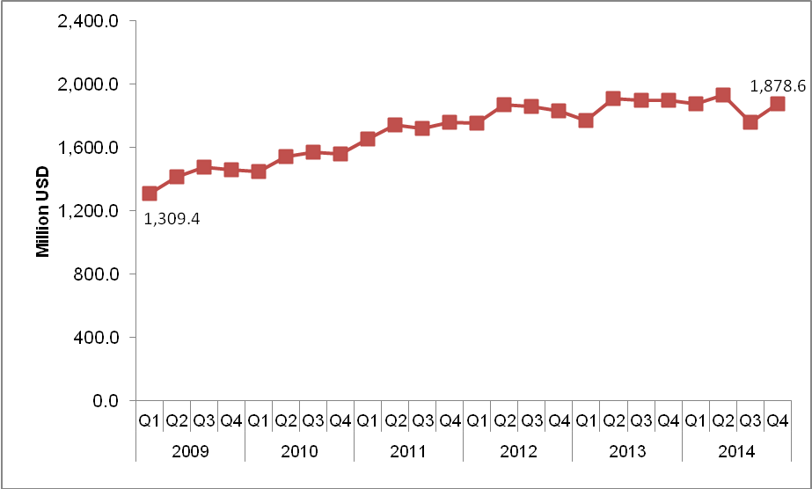

* The data excludes those parts of Jerusalem governorate which were annexed by Israel in 1967.

