Palestinian Central Bureau of Statistics

Preliminary Estimates of Quarterly National Accounts

(Second Quarter 2015)

Main Results

Increase in GDP at constant prices in Palestine* during the 2nd quarter 2015 compared to the parallel quarter (2nd quarter 2014)
Preliminary estimates at constant prices showed an increase of 2.1% in GDP in Palestine* during the 2nd quarter 2015 compared to the 2nd quarter 2014, (increase 3.3% in West Bank* and decrease 1.5% in Gaza Strip). And it showed an increase of 6.0% in Palestine* compared to the 1st quarter 2015 at constant prices, and the base year is 2004. GDP for the 2nd quarter 2015 at constant prices was USD 1,501.3 million for West Bank* and USD 473.5 million for Gaza Strip.

Gross Domestic Product Per Capita
GDP per Capita for Palestine* at constant prices was USD 448.2 during the 2nd quarter 2015, it showed a decrease of 0.9% compared to the 2nd quarter 2014. As for West Bank* at constant prices it was USD 578.8 during the 2nd quarter 2015, it showed an increase by 0.6% during the 2nd quarter 2015 compared to the 2nd quarter 2014, and for Gaza Strip was USD 261.2 during the 2nd quarter 2015, and it showed a decrease by 4.8% during the 2nd quarter 2015 compared to the parallel quarter 2014.

Quarterly GDP in Palestine* at Constant Prices for the Years 2010-2015
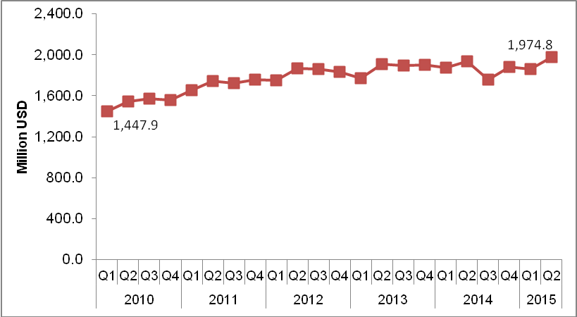
* The data excludes those parts of Jerusalem governorate which were annexed by Israel in 1967.

*

