Palestinian Central Bureau of Statistics "PCBS"& Ministry of Agriculture "MoA"
Result Of Olive presses Survey In Palestine, 2014

Increase in olive oil production in 2014

The quantity of oil extracted in Palestine was 24,758.5 tons in 2014, showing an increase of 40.3% compared to 2013.

The total quantity of olives pressed in 2014 was 108,379.1 tons: 26.5% of these in Jenin and Tubas governorates and 12.2% in Nablus governorates.

The value added of olive pressing activities totaled USD 10.9 million in 2014, while intermediate consumption and output of olive presses totaled around USD 3.1 million and USD 14.0 million respectively.

A total of 265 olive presses were in operation in Palestine, of which 241 were fully automatic presses and 24 were either half automatic or traditional presses.

The finding of the survey show that 1,353 workers were employed in olive pressing activities in 2014, of these 72.8% were waged employees with compensation totaling about USD 1.0 million.

Quantity of Pressed Olive and Extracted Oil in Palestine for Years 2004-2014
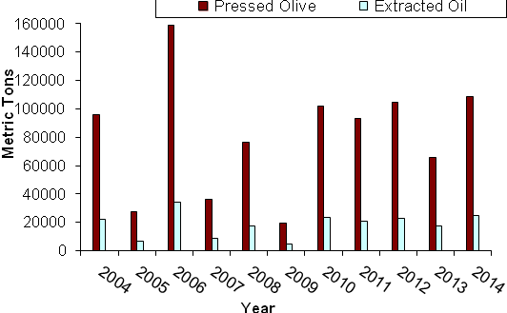

Quantity of Pressed Olive and Extracted Oil in Palestine by Region, 2014
