Palestinian Central Bureau of Statistics (PCBS)

Press Release On Olive Press Survey In Palestine, 2013

Fall in olive oil production in 2013:
The quantity of oil extracted in Palestine was 17,642 tons in 2013, a decrease of 23.1% compared to 2012.

The total quantity of olives pressed in 2013 was 65,829 tons: 23.0% of these in Jenin and Tubas governorates and 20.2% in Ramallah and Al-Bireh
governorates.

The value added of olive pressing activities totaled USD 6.5 million in 2013, while intermediate consumption and output of olive presses totaled around USD 2.1 million and USD 8.6 million respectively.

A total of 264 olive presses were in operation in Palestine, of which 230 were fully automatic presses and 34 were half automatic and traditional presses.

The survey results show that 1,119 persons participated in olive pressing activities in 2013. Of these 64.0% were waged employees with compensation totaling about USD 0.7 million.

Quantity of Pressed Olive and Extracted Oil in Palestine for Years 2003-2013

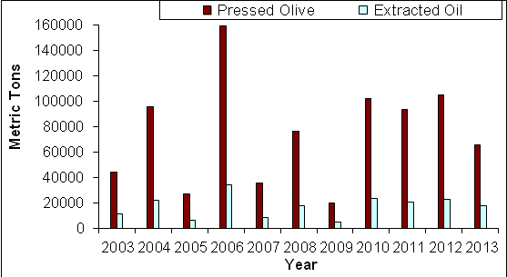

Quantity of Pressed Olive and Extracted Oil in Palestine by Region, 2013

