Palestinian Central Bureau of Statistics (PCBS)

Preliminary Estimates of Quarterly National Accounts

(Second Quarter 2014)

Main Results

An increase in GDP at constant prices in Palestine* during the 2nd quarter 2014 compared to the parallel quarter (2nd quarter 2013)
Preliminary estimates at constant prices showed an increase of 3.9 percent in GDP in Palestine* during the 2nd quarter 2014 compared to the 2nd quarter 2013, (increase 8.0% in West Bank* and decrease 7.1% in Gaza Strip). And it showed an increase of 5.1 percent in Palestine* compared to the 1st quarter 2014 at constant prices, and the base year is 2004. GDP for the 2nd quarter 2014 at constant prices was USD 1,493 million for West Bank* and USD 481 million for Gaza Strip.

Gross Domestic Product Per Capita
GDP per Capita for Palestine* at constant prices was USD 461 during the 2nd quarter 2014, it showed an increase of 0.9 percent compared to the 2nd quarter 2013. As for West Bank* at constant prices it was USD 591 during the 2nd quarter 2014, it showed an increase by 5.2 percent during the 2nd quarter 2014 compared to the 2nd quarter 2013, and for Gaza Strip was USD 274 during the 2nd quarter 2014, and it showed a decrease by 10.2 percent during the 2nd quarter 2014 compared to the parallel quarter 2013.

Quarterly GDP in Palestine* at Constant Prices for the Years 2009-2014
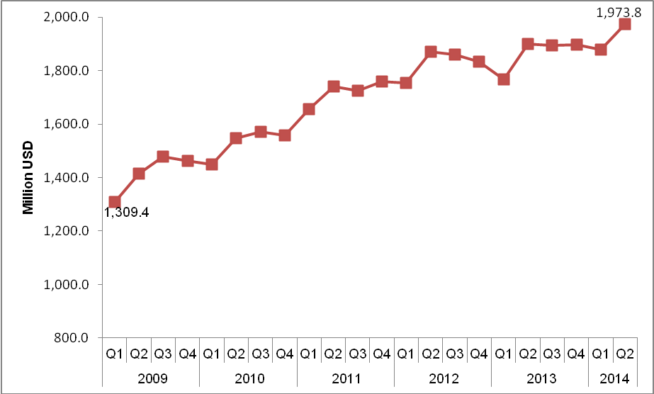

* The data excludes those parts of Jerusalem which were annexed by Israel in 1967.

