Palestinian Central Bureau of Statistics (PCBS)

Press Release by Palestinian Central Bureau of Statistics (PCBS) on the Occasion of the Land Day, March 30, 2015

The Palestinian people, every year, commemorate the Land Day that coincides with the confiscation of 21 thousand dunums of their land in the Jalil, Al-Muthalath and the Naqab on 30 March 1976; this year again the Israeli responded fiercely killing six young demonstrators.

Jerusalem; Systematically Judaizing

The Israeli occupation authorities do not only demolish Palestinian houses but also hinder the issuance of any building licenses for Palestinians in Jerusalem and its boundaries.

According to Al-Maqdisi Institute, between 2000 and 2014, the Israeli authorities demolished 1,342 buildings in East Jerusalem (the areas annexed by Israel in 1967). This has resulted in the displacement of 5,760 people.

Data show an increase in the cases of residents forced to demolish their own houses: 340 people were forced to demolish their own homes during the period 2000-2014, the highest rate of self-demolition was recorded in 2010 with 70 demolitions and 49 in 2009.

Self-Demolition 2000-2014

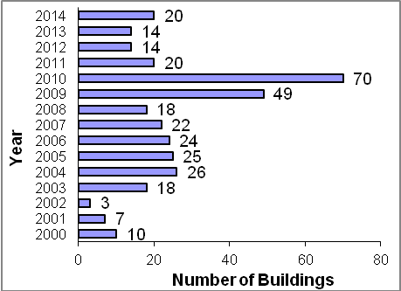

About Half of Israeli Settlers Live in Jerusalem Governorate

There were 409 Israeli locations in the West Bank (including settlements, outposts and military bases) by the end of 2013. Data indicate that the total number of settlers in the West Bank was 580,801 at the end of 2013; 281,684 settlers live in Jerusalem Governorate and constitute 48.5% of all settlers occupying the West Bank: 206,705 of them live in areas of Jerusalem annexed by Israel in 1967. In demographic terms, the proportion of settlers to the Palestinian population in the West Bank is around 21 settlers per 100 Palestinians compared with 69 settlers per 100 Palestinians in Jerusalem governorate.

Israeli Settlers Use More Than 50 Million m³ of Water from the Palestinians Water to Cultivate the Land Seized by the Israeli Occupation

Data from the Ministry of Planning on the national strategic framework for the development of policies and interventions in the Area C, based on World Bank report indicates that the total cultivated area in Israeli settlements in the West Bank during 2013 was about 100 km². The majority of the land is irrigated using more than 50 million m³ of the Palestinians ground water. Irrigated areas cultivated by Palestinians 2011, are about 78 km².

Israel Controls More Than 85% of Land of Historical Palestine

Historical land area of Palestine reached, 27,000 km², Israel uses more than 85% of the total area of the land, while the Palestinian comprise 48% of the total population and use less than 15% of the land, a Palestinian therefore has less than a fifth of the area available to an Israeli.

Israeli Occupation Plunders the Natural Resources of Palestine State

International law prohibits Israel from exploiting the natural resources of the occupied territories, but Israel continues regardless and treats Palestinian land as its own, Regarding to Area C, that is located under the Israeli control and constitutes 60% of the West Bank area according to Oslo agreement, Palestinians are prevent from utilization the resources that located in it due to the Israeli militaries and the annexation wall that isolate 10% of the West Bank area.

Israel has taken over the management of tourist sites in the Jordan valley: Solomon’s caves, Al Fashkha spring and the protected area of Wadi Al-Qilt.

Israel exploits the Palestinian beaches of the Dead Sea and prevents Palestinians from developing tourism in this region by disposing of wastewater and solid waste from Israeli settlements and industrial zones in these areas according to the Israeli Information Center for Human Rights in the Occupied Territories (B’Tselem) .

The occupation authorities have started to drill and explore for oil and natural gas in the West Bank to deprive Palestinians from these resources.

Thousands of buildings were destroyed during the Israeli aggression on Gaza Strip in 2014

Data indicate that the number of completely destroyed housing units during the Israeli aggression on the Gaza Strip in summer 2014 was about 9 thousand units. Moreover, 47 thousand housing units suffered partial destruction. Moreover, 327 schools were completely destroyed, 50% of which served double shifts. In addition, six universities that were partially destroyed. Holy places did not survive the attack either with the destruction of 71 mosques and some churches. 20 government buildings were completely destroyed, in addition to the destruction of 29 hospitals and primary health care centers.

