Palestinian Central Bureau of Statistics (PCBS)

Press Release by Palestinian Central Bureau of Statistics (PCBS) on the Occasion of Land Day, March 30, 2014

The Palestinian people protests yearly against the confiscation of 21 thousand dunums of land in the Jalil, Al-Muthalath and the Naqab on the 30th of March 1976, the Israeli response resulted in the death of six young demonstrators.

Jerusalem; Systematically Judaizing
The Israeli occupation authorities demolish Palestinian houses and impose obstacles and constraints on building licenses for Palestinians. According to Al-Maqdisi Institute, during 2000 - 2013, the Israeli authorities demolished 1,230 buildings in East Jerusalem (the areas annexed by Israel in 1967). This has resulted in the displacement of 5,419 people, including 2,832 children and 1,423 women.

The estimated losses to Palestinians of the demolition of buildings in Jerusalem total around three and half million US dollars. (This does not include the large fines imposed on so-called construction violations.) Data indicate an increase in cases where residents have to demolish their own houses: 320 people have been forced to demolish their own homes since 2000.

The highest rate of self-demolition was recorded in 2010 with 70 demolitions compared to 49 in 2009.

Self-Demolition 2000-2013

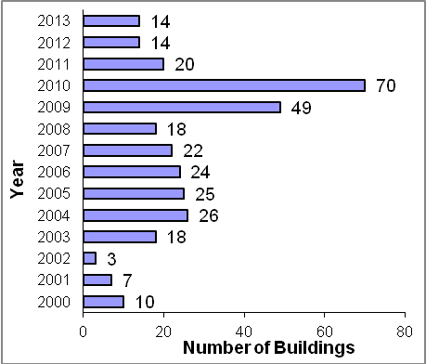

Data indicate that the total area of residential houses demolished in Jerusalem during 2013 increased in comparison with 2012. A total area of 6,196 m²​ was affected during 2013: the area of non-residential establishments demolished totaled 1,150 m².

Data from Israeli human rights organizations indicate that more than 25 thousand houses have been demolished in Palestine since 1967.

Half of Israeli settlers live in Jerusalem governorate
There were 482 Israeli locations in the West Bank (including settlements, outposts and military bases) by the end of 2013. Data indicate that the total number of settlers in the West Bank was 563,546 at the end of 2012; 277,501 settlers live in Jerusalem governorate and constitute 49.2% of all settlers occupying the West Bank: 203,176 of them live in areas of Jerusalem annexed by Israel in 1967. In demographic terms, the proportion of settlers to the Palestinian population in West Bank is around 21 settlers per 100 Palestinians compared with 69 settlers per 100 Palestinians in Jerusalem governorate.

Israeli settlers use 50 million m3 of stolen water from the Palestinians to cultivate the land seized by the Israeli occupation
According to Israeli statistics, the total cultivated area in Israeli settlements in the West Bank during 2012 was 86 km². The majority of land is irrigated with around 50 million m³ of stolen water from the Palestinians per year. Irrigated areas cultivated by Palestinians are about 78 km² consuming around 30 million m³ of water per year only due to the Israeli restrictions. The areas cultivated and water consumed by settlers would provide 100 thousand job opportunities for Palestinians in the West Bank if they were able to take advantage of them. This would contribute to GDP and the share of agriculture to the economy. It would also reduce the unemployment rate. In addition, a large agricultural area is located at the borders of the eastern Gaza Strip, but cannot be utilized by Palestinians because of Israeli measures.

Israel controls more than 85% of land of historical Palestine
Historical land area of Palestine reached, 27,000 km², Israel uses more than 85% of the total area of the land, while the Palestinian comprise 48% of the total population and use less than 15% only of the land, a Palestinian therefore has less than a fifth of the area available to an Israeli.

Israeli occupation approves over 2,000 housing units monthly
During 2013, more than eight thousand dunums of land were confiscated from Palestinians and more than 15 thousand horticultural trees were destroyed, causing considerable damage to the Palestinian environment. The Israeli occupation authorities also approved the establishment of more than 23 thousand housing units concentrated in settlements around Jerusalem governorate, according to the annual report issued by the International Relations Department of the PLO.

Israeli occupation plunders the natural resources of the West Bank
International law prohibits Israel from exploiting the natural resources of the occupied territories, but Israel continues regardless and treats Palestinian land as its own. Israel has taken over the management of tourist sites in the Jordan valley: Solomon’s caves, Al Fashkha spring and the protected area of Wadi Al-Qilt.

Israel exploits the Palestinian beaches of the Dead Sea and prevents Palestinians from developing tourism in this region by disposing of wastewater and solid waste from Israeli settlements and industrial zones in these areas according to the Israeli Information Center for Human Rights in the Occupied Territories (B’Tselem) .

The occupation authorities have started to drill and explore for oil and natural gas in the West Bank to deprive Palestinians of these resources.

