Palestinian Central Bureau of Statistics (PCBS)

Press Release on the Results of the Labour Force Survey in Palestine, 2015.

45.8% was the labour force participation rate of persons aged 15 years and above

The number of persons participating in the labour force in Palestine was 1,299 thousands in 2015; 828 thousands in the West Bank and 471 thousands in Gaza Strip.

The labour force participation rate in the West Bank was 46.1% and 45.3% in Gaza Strip in 2015, the gap in the participation rate between males and females in Palestine still very big where it reached 71.9% for males compared with 19.1% for females in 2015.

25.9% the unemployment rate among labour force participants in 2015

Using ILO standards, the number of unemployed was 336 thousands in 2015; distributed as 193 thousands in Gaza Strip and 143 thousands in the West Bank.

The unemployment rate in Gaza Strip was 41.0% compared with 17.3% in the West Bank in 2015. And the unemployment rate for males in Palestine was 22.5% compared with 39.2% for females in 2015.

The seasonality affected the Unemployment rate during the year; the unemployment rate trended to increase during the quarters of year 2015 in both Gaza Strip and the West Bank.

Unemployment Rate Among Labour Force Participants by Region, Quarters of 2015

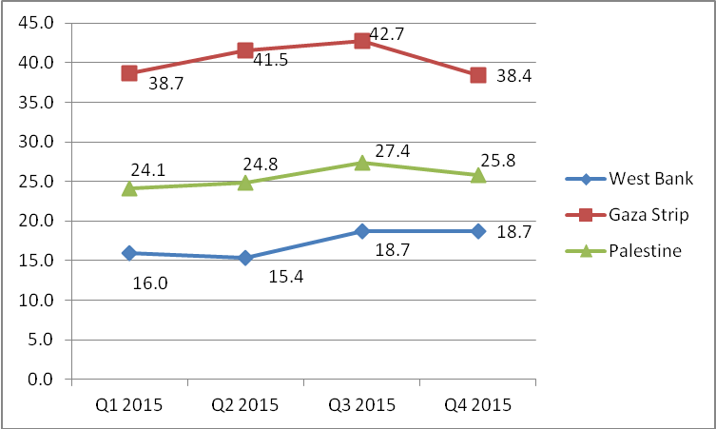

The highest unemployment rate in 2015 was 36.5% among youth aged 20-24 years. For years of schooling, the highest unemployment rate among females with 13 years of schooling and more was 48.0%.

Ramallah and Al- Bireh & Hebron governorates were the highest unemployment rate in the West Bank while Deir AL-Balah governorate in Gaza Strip

The highest unemployment rates in the West Bank governorates was registered in Ramallah and Al- Bireh governorate with 19.7% followed by Hebron governorate with 19.5%, while the lowest rate in the West Bank was in Qalqiliya with 13.2%. In Gaza Strip, Deir ALBalah governorate registered the highest unemployment rate at 48.0% followed by Khan Younis with 42.5%, while the lowest rate was in Gaza governorate with 36.5% in 2015.

Unemployment Rate Among Labour Force Participants by Governorate, 2015

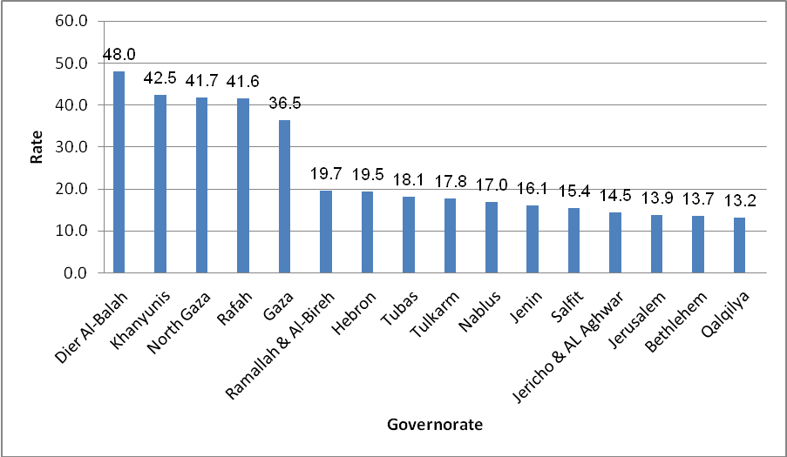

88.3% of employed persons work in the local labour market in 2015

The number of employed in the local market was 846 thousands in 2015. The number of employed persons in the West Bank was 570 thousands employed and 276 thousands employed in Gaza Strip. About 162 thousands employed woman in 2015; distributed as 121 thousands employed woman in the West Bank and 41 thousands employed woman in Gaza Strip.

11.7% of employed persons work in Israel and Israeli Settlements in 2015

The number of employed persons from the West Bank employed in Israel and Israeli settlements was 112,300 in 2015. Of these, 63,000 had a permit, 36,400 worked without any permit and 12,900 employed persons have an Israeli identity card or foreign passport. The number of employed persons in the Israeli settlements was 22,400 in 2015.

103.9 NIS was the average daily wage for wage employees in 2015

The average daily wage for the wage employees from Palestine was 103.9 NIS, by place of work, The average daily wage for the wage employees in the West Bank was 94.1 NIS, in Gaza Strip was 61.9 NIS, while in Israel and Israeli settlements was 198.9 NIS.

