Palestinian Central Bureau of Statistics (PCBS)

Press Release on Israeli Settlements in Palestine

Around 600 thousands Settlers in the
West Bank, Half of them are in Jerusalem Governorate

There were 150 settlements in the West Bank at the end of 2014. The majority are located in Jerusalem governorate: 26 settlements, of which 16 are on land annexed by Israel (J1), and 10 settlements in Jerusalem (J2).

Number of Israeli Settlements in the West Bank by Governorate, 2014
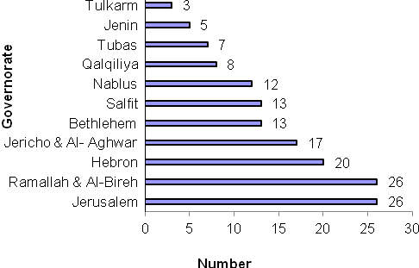

Data indicate that the number of settlers in the West Bank at the end of 2014 was 599,901.

Number of Settlers in the West Bank Settlements by Year and Region 2009 -2014
Year | Region
Year | Jerusalem (J1)¹ | West Bank
2009 | 192,768 | 506,869(R)
2010 | 196,178 | 524,952(R)
2011 | 199,647 | 542,997(R)
2012 | 203,176 | 562,747(R)
2013 | 206,767(R) | 580,762(R)
2014 | 210,420 | 599,901

R: revised data

Most settlers (286,997) are concentrated in Jerusalem governorate, constituting 47.8% of all settlers in the West Bank. Of these, 210,420 settlers are in the Jerusalem (J1) area. Other settlers are in Ramallah & Al-Bireh governorate (120,417 settlers), Bethlehem governorate (72,626 settlers), and Salfit governorate (37,350 settlers). The governorate with the lowest number of settlers was Tubas with 1,845 settlers.

Number of Israeli Settlers in the West Bank by Governorate, 2014
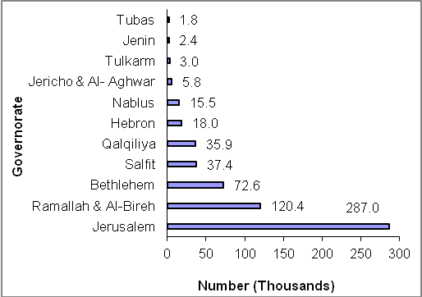

Includes that part of Jerusalem which was annexed forcefully by Israel following its occupation of the West Bank in 1967

