Palestinian Central Bureau of Statistics (PCBS)

On the Eve of International Youth Day 12/8/2013

On the eve of International Youth Day, the PCBS releases a statistical review on the status of Palestinian youth:

Youth comprises one third of Palestinian Society
The estimated population in the Palestine totaled 4.42 million in mid-2013 (50.8% male and 49.2% female) with a ratio of 103.2 males per 100 females.

Youth represents 29.9% of the total population: 38.8% of them are adolescents and 61.2% are youth. The sex ratio among youth is 104.2 males per 100 females.

Population Pyramid in the Palestine, Mid-2013

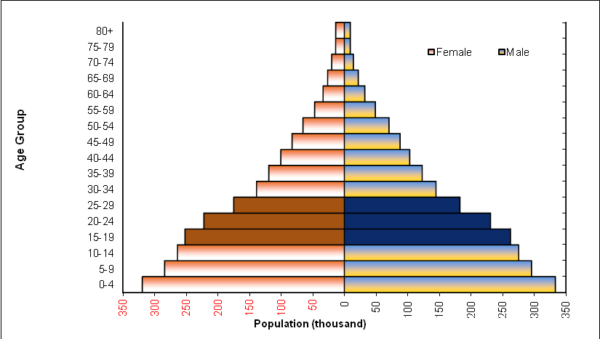

Marriage and divorce rates higher among females aged 15-29
According to the 2012 database of registered marriages and divorces, 92.1% of females were in the age group of 15-29 years are married compared to 80.4% of males. 77.4% of divorced females were aged between 15-29 years compared with 56.4% for divorced males.

The 2010 data showed that 30.2% of marriages for ever married women (15-29 years) were married of first consanguinity to their husbands while 54.9% of marriages had no relative with husbands.

Total fertility rate in Gaza Strip remain higher than the west bank
According to the final results of the Palestinian Family Survey of 2010, the total fertility rate in the Palestine declined to 4.4 births between (2008-2009) compared to 4.6 births in 2006. At the region level, the total fertility rate in the West Bank between (2008-2009) was 4.0 birth compared with 5.2 birth in Gaza Strip. Females aged 25-29 years contribute 26.0% of the total fertility rate, the highest contributor of all age groups.

Age-Specific Fertility Rates and Total Fertility Rates by Region, 2008-2009
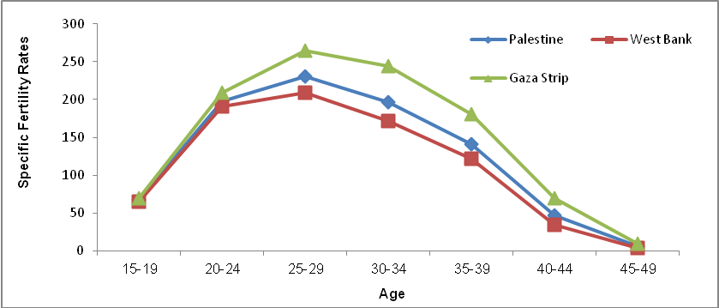

43.1% of youth (15-29 years) were enrolled in education in 2012
In 2012, 43.1% of youth aged 15-29 years were enrolled in education; 83.9% in the age group of 15-17 years, 48.3% in the age group of 18-22 years, and 11.9% in the age group of 23-29 years. Dropout rates (both of those who were previously enrolled and left or failed to attend) were 31.0%; 36.0% for males and 25.8% for females.

Young female more enrollment at higher education than young males
In addition, 8.7% of males aged 15-29 years hold a university degree compared to 11.9% of females in the same age group. A further 3.0% of males had not completed any educational stage compared to 1.7% of females in the age group of 15-29 years. Furthermore, 0.7% of youth aged 15-29 years are illiterate; 0.7% males and 0.8% females.

Half of young graduates are unemployed
The unemployment rate among youth graduates was 52.5% in the first quarter of 2013. The highest unemployment rate was 64.7% for graduates in education and teacher training, while the lowest unemployment rate of 24.1% was among law graduates.

Almost half of youth do not read newspapers and magazines
Among 49.9% of youth aged 15-29 years in the Palestine do not read newspapers or magazines at all; 40.4% in the West Bank and 65.3% in Gaza Strip. Also, 87.4% of youth in the Palestine watch television on a daily basis compared to 27.4% who listen to the radio daily, while 25.0% of youth use the Internet.

The majority of youth use the Computer
Data on information technology during previous years indicated that there had been a remarkable development in indicators regarding access and the use of information and communication technology among young people in the age group of 15-29 years. The data reported in 2011 showed that the proportion of young people who use the computer was 67.5% in the Palestine (70.4% in the West Bank and 62.7% in Gaza Strip), compared with 47.6% in 2004. The gap among both sexes in using of computers narrowed to 69.8% among males compared to 65.0% among females in 2011.

43.0% of youth use e-mail
In 2011, 42.9% of youth in the Palestine possessed an e-mail account (45.9% in the West Bank and 38.2% in Gaza Strip) compared with 14.3% in 2004. In 2011, 51.1% of males possessed an email account compared to 34.4% of females.
Three-quarters of youth use a mobile phone
In 2011, the percentage of young people who own a mobile phone rose to 75.2% in the Palestine (79.4% in the West Bank against 68.5% in the Gaza Strip) compared to 34.9% in 2004. This ratio varied significantly by gender with 86.3% among males and 63.7% among females owning a mobile phone according to data of 2011.
The majority of youth evaluated their health as good
In 2010, 83.9% of youth aged 15-29 years evaluated their health as good; 86.2% of males and 80.6% of females. Sport activities were being exercised regularly by 33.5% of youth; 35.6% in the West Bank and 30.1% in the Gaza Strip.

About three in every 100 youth suffered from one chronic disease at least
In the Palestine, 2.5% of youth aged 15-29 years reported that they suffered from at least one chronic disease; 2.8% of males and 2.1% of females.

Prevalence of chronic diseases among youth aged 15-29 years

by sex and region, 2010

Sex | Palestinian Territory | West Bank | Gaza Strip
Both sexes | 2.5 | 2.7 | 2.2
Males | 2.8 | 3.0 | 2.4
Females | 2.1 | 2.3 | 1.9

More than one quarter of Male youth smoke
In the Palestine, 15.1% of youth in the age group of 15-29 years reported that they smoke; 28.7% male and 0.9% female.

Prevalence of smoking among youth aged 15-29 years

by sex and region, 2010

Sex | Palestinian Territory | West Bank | Gaza Strip
Both sexes | 15.1 | 19.8 | 7.3
Males | 28.7 | 37.4 | 14.3
Females | 0.9 | 1.4 | 0.1

More than a third of youth unemployed during the first quarter 2013
The data of labor force survey for the first quarter of 2013 showed that 37.0% of youth aged 15-29 years are economically active (employed and unemployed); 39.2% in the West Bank and 33.5% in the Gaza Strip. The youth unemployment rate totaled in the Palestine at 37.0%. The highest unemployment rate was 41.1% in the age group of 20-24 years compared with 31.8% for the age group of 25-29 years. In addition, 45.7% of those unemployed had completed at least 13 schooling.

The services sector and its branches observed 28.8% of youth (15-29 years), while the commerce sector, restaurants, and hotels worked at 22.9% of that age group.

More than a quarter of youth in the Palestine suffered from poverty during the year of 2011
The relative poverty line and the deep poverty line according to consumption patterns (for reference household consisted of 2 adults and 3 children) in the Palestine in 2011 were 2,293 NIS, and 1,832 NIS respectively. The poverty rate among Palestinian individuals was 25.8 (17.8% in the West Bank, and 38.8% in Gaza Strip). 12.9% of the individuals in the Palestine were suffering from deep poverty in 2011 according to consumption patterns (7.8% in the West Bank, and 21.1% in Gaza Strip). While 27.4% of youth 15-29 years are under the poverty rate (19.2% in the West Bank and 40.9% in the Gaza Strip.

Females more vulnerable to violence
Data of the violence survey in Palestinian society 2011 indicated that 20.8% of the youth aged (18-29) were vulnerable to one type of violence at the least (19.4% for males against 33.2% for females).

One third of the youth who were vulnerable to psychiatric violence (31.4%), and 38.7% were vulnerable to physical violence while 1.1% of them were vulnerable to sexual violence.

