Palestinian Central Bureau of Statistics (PCBS)

On the occasion of May 1st - International Workers Day

Ms. Ola Awad, President of PCBS, presents the current status of Palestinian labour force during 2014

Participation of men in the labour force is about four times higher than the participation of women
The participation rate in the labour force of persons aged 15 years and above in Palestine was 46% distributed as 72% for males and 19% for females. On the level of the West Bank, the participation rate was 47%; 73% for males compared to 19% for females. Regarding Gaza Strip, about 44% of persons participated in the labour force; 68% for males and 20% for females.

Labour Force Participation Rate of Persons Aged 15 Years and Above by Sex, 2007-2014

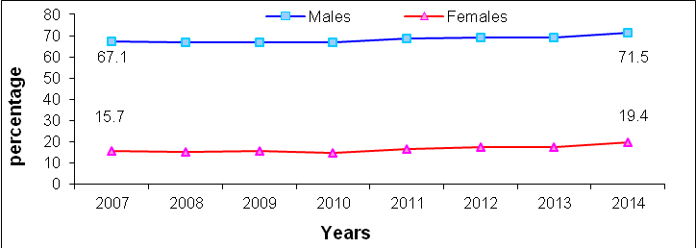

High unemployment rates
The unemployment rate among participants in the labour force aged 15 years and above in Palestine was 27% (About 338 thousand persons were unemployed); 24% for males and 38% for females. The unemployment rate in the West Bank was 18% ( about 143 thousand); 15% for males and 27% for females, compared with 44% in Gaza Strip (about 195 thousand); 40% for males and 57% for females.

Unemployment Rate Among labour Force Participants of Persons Aged 15 Years and Above by Region, 2007-2014

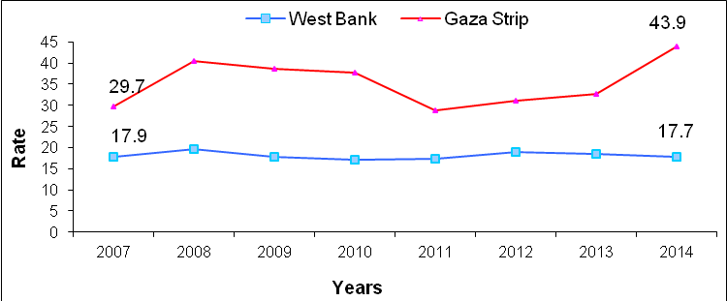

618 thousand of employed are wage employees
The number of wage employees in Palestine amounted to 618 thousand, of whom 331 thousand employed in the West Bank and 188 thousand employed in Gaza Strip; while 78 thousand employed in Israel and 21 thousand employed in Israeli settlement.

The Public Sector is the dominant employer in Gaza Strip
Wage employees distributed in Palestine About 50% in the private sector compared with 34% work in the public sector; while the percentage of workers in Israel and Israeli settlements reached 16%.
Regarding wage employees in the West Bank, more than half employees 52% work in the private sector compared with 25% in the public sector and 23% work in Israel and Israeli settlements. The public sector was the largest employer in Gaza Strip with 55% compared with 45% in the private sector.

About one fourth of wage employees in the private sector work in technical and specialized occupations
About 26% of wage employees work as professionals or technicians in Palestine; 16% for males and 67% for females. In addition, 18% of wage employees in Palestine work in craft and related trade worker; 21% for males and 3% for females.

On the other hand, about 20% of wage employees in the private sector in Palestine received vocational training; 19% in the West Bank and 22% in Gaza Strip.

Low average real wages in the private sector
The average daily real wage ( base year= 2010) in the private sector in Palestine was 70 NIS; 75 NIS in the West Bank (workers in Israel and Settlements are excluded) and 51 NIS in Gaza Strip.

Services sector in the private sector recorded the highest average daily real wage at 88 NIS in the West Bank and 80 NIS in Gaza Strip, followed by construction sector with 82 NIS in the West Bank and 52 NIS in Gaza Strip. The agriculture sector recorded the lowest average daily wage at 55 NIS in the West Bank and 24 NIS in Gaza Strip.

About 33% of wage employees in the private sector received less than the minimum wage (1,450 NIS) in Palestine.
In West Bank, about 23% of wage employees in the private sector received less than minimum monthly wage about 50,900 wage employees with an average of monthly wage by 1,035 NIS. The large number of those who received less than the minimum monthly wage was in Hebron governorate of about 14,000 persons with average of monthly wage by 955 NIS.

In Gaza Strip, the percentage of wage employees in the private sector who received less than minimum monthly wage was 60% of about 50,700 wage employees with an average of monthly wage 718 NIS. The large number of those who received less than the minimum monthly wage was in Gaza governorate of about 21,100 persons with an average of monthly wage by 754 NIS.

The average actual weekly work hours in Palestine was 42 hours; 39 hours for wage employees in the public sector, 44 hours in the private sector.

About one fifth of wage employees received retirement benefits
About 21% of wage employees received retirement or end of service benefits; while 22% received paid annual leave, 35% of wage employees females received paid maternity leave and 22% received paid annual sick leave.

More than one fourth of wage employees in the private sector have work contract
28% of wage employees in the private sector have work contract in Palestine; 25% in the West Bank and 35% in Gaza Strip.

More than one fourth of wage employees in the private sector are affiliated to labour or professional unions
22% of wage employees in Palestine were affiliated to labour or professional union; 13% in the West Bank and 44% in Gaza Strip.

Data collection of labour force survey was funded by the European Union.

