Palestinian Central Bureau of Statistics (PCBS)

On the occasion of May 1st - International Workers Day

Ms. Ola Awad, President of PCBS, presents the current status of Palestinian labour force during 2012

Participation of men in the labour force is four times higher than the participation of women
The participation rate in the labour force of persons aged 15 years and above in Palestine was 44% distributed as 69% for males and 17% for females. On West Bank level, the participation rate was 46%; 71% for males compared to 19Gaza Strip, about 40% of persons participated in the labour force; as 65% for males and 15% for females.

Labour Force Participation Rate of Persons Aged 15 Years and Above by Sex, 2006-2012

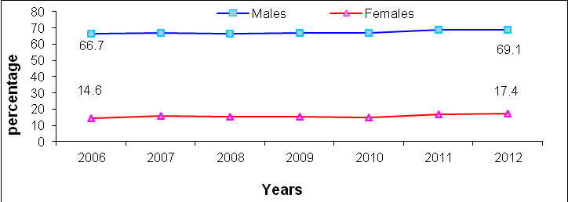

High unemployment rates
The unemployment rate among participants aged 15 years and above in Palestine was 23% (About 256 thousand persons were unemployed); as of 21% for males and 33% for females). The unemployment rate in the West Bank was 19% ( about 141 thousand); as of 17% for males and 25% for females compared with 31% in Gaza Strip (115 thousand); as of 27% for males and 50% for females.

Unemployment Rate of Participants in the Labour Force Aged 15 Years and Above by Region, 2006-2012

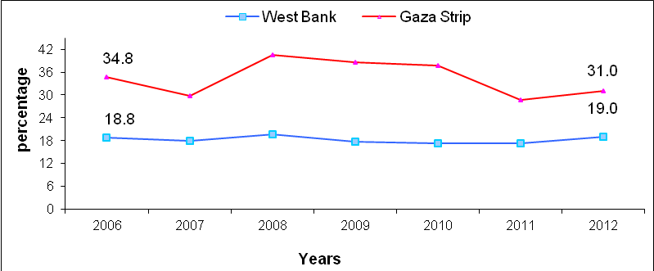

574 thousand of employed are employees
The number of wage employees in Palestine amounted to 574 thousand, of whom 307 thousand employed in the West Bank and 190 thousand employed in Gaza Strip; while 63 thousand employed in Israel and 14 thousand employed in Israeli settlements.

The Public Sector is the dominant employer in Gaza Strip
About 53% of wage employees in Palestine worked in the private sector compared with 34% employed by the public sector; while the percentage of workers in Israel and Israeli settlements reached 13%.
Regarding wage employees in the West Bank, more than half of them as about 55% worked in the private sector compared with 25% in the public sector and 20% work in Israel and Israeli settlements. The public sector was the largest employer in Gaza Strip with 52% compared with 48% in the private sector.

About one fifth of wage employees are poor:
About 22% of wage employees are poor in Palestine in 2011; 16% in the West Bank and 35% in Gaza Strip.

One forth of wage employees in the private sector work in technical and specialized occupations:
About 25% of wage employees work as professionals or technicians in Palestine; 17% for males and 66% for females. Moreover, 18% of wage employees in Palestine work in craft occupations; 21% for males and 4% for females.

On the other hand, about 18% of wage employees in Palestine received vocational training; 18% in the West Bank and 20% in Gaza Strip.

Low average real wages in the private sector:
The average daily real wage in Palestine was NIS 54 for both sexes males and females; NIS 60 in the West Bank (workers in Israel and Settlements are excluded) and 42 in Gaza Strip.

About the nominal wage, services sector in the private sector recorded the highest average daily wage at 105 NIS in the West Bank and NIS 94 in Gaza Strip, followed by transport and communication sector with NIS 95 in the West Bank and NIS 43 NIS in Gaza Strip. The agriculture sector recorded the lowest average daily wage at NIS 60 in the West Bank and NIS 24 in Gaza Strip.

The average weekly work week in hours in Palestine was 41 hours; distributed as 39 hours for employed persons in the public sector, 42 hours in the private sector.

About one forth of wage employees received retirement benefits
About 24% of wage employees received retirement or end of service benefits; while 25% received paid annual leave and paid annual sick leave. In addition, 54% of wage employees females received paid maternity leave.
More than 95% of wage employees in the public sector received most of work related benefits and privileges such as paid sick leave, annual leave, maternity leave,…etc.

Less than one third of wage employees in the private sector have work contract
28% of wage employees in the private sector have work contract in Palestine; 28% in the West Bank and 27% in Gaza Strip.

Less than one third of wage employees in the private sector are affiliated to labour or professional unions
29% of wage employees in Palestine were affiliated to labour or professional union; 16% in the West Bank and 59% in Gaza Strip.

