Palestinian Central Bureau of Statistics (PCBS)

On the occasion of May 1st - International Workers Day

Ms. Ola Awad, President of PCBS, presents the current status of Palestinian labour force during 2015

Participation of men in the labour force is about four times higher than the participation of women
The participation rate in the labour force of persons aged 15 years and above in Palestine was 46% distributed as 72% for males and 19% for females. On the level of the West Bank, the participation rate was 46%; 73% for males compared to 19% for females. Regarding Gaza Strip, about 45% of persons participated in the labour force; 70% for males and 20% for females.

Labour Force Participation Rate of Persons Aged 15 Years and Above by Sex, 2010-2015
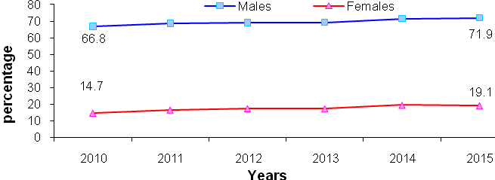

High unemployment rates
The unemployment rate among participants in the labour force aged 15 years and above in Palestine was 26% (About 336 thousand persons were unemployed); 23% for males and 39% for females. The unemployment rate in the West Bank was 17% ( about 143 thousand); 15% for males and 27% for females, compared with 41% in Gaza Strip (about 193 thousand); 36% for males and 60% for females.

Unemployment Rate Among labour Force Participants of Persons Aged 15 Years and Above by Region, 2010-2015
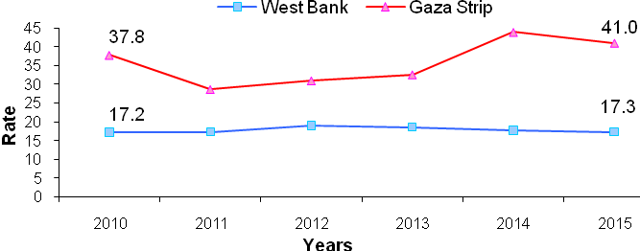

659 thousand of employed are wage employees
The number of wage employees in Palestine amounted to 659 thousand, of whom 338 thousand employed in the West Bank and 216 thousand employed in Gaza Strip; while 83 thousand employed in Israel and 22 thousand employed in Israeli settlement.

The Public Sector is the dominant employer in Gaza Strip
Wage employees distributed in Palestine as follows: about 52% in the private sector compared with 32% work in the public sector; while the percentage of workers in Israel and Israeli settlements reached 16%.
Regarding wage employees in the West Bank, more than half of the employees 51% work in the private sector compared with 25% in the public sector and 24% work in Israel and Israeli settlements. The public sector was the largest employer in Gaza Strip with 53% compared with 47% in the private sector.

About one fourth of wage employees in the private sector work in technical and specialized occupations
About 25% of wage employees work as professionals or technicians in Palestine; 15% for males and 66% for females. In addition, 18% of wage employees in Palestine work in craft and related trade worker; 21% for males and 3% for females.

Low average real wages in the private sector
The average daily real wage (base year: 2010) in the private sector in Palestine was 68 NIS; 77 NIS in the West Bank (workers in Israel and Settlements are excluded) and 48 NIS in Gaza Strip.

Services sector in the private sector recorded the highest average daily real wage at 93 NIS in the West Bank and 76 NIS in Gaza Strip, followed by construction sector with 83 NIS in the West Bank and 40 NIS in Gaza Strip. The agriculture sector recorded the lowest average daily wage at 62 NIS in the West Bank and 24 NIS in Gaza Strip.

About 36% of wage employees in the private sector received less than the minimum wage (1,450 NIS) in Palestine.
In the West Bank, about 21% of wage employees in the private sector received less than minimum monthly wage about 47,600 wage employees with an average of monthly wage by 1,055 NIS. The large number of those who received less than the minimum monthly wage was in Hebron governorate of about 12,700 persons with average of monthly wage by 986 NIS.

In Gaza Strip, the percentage of wage employees in the private sector who received less than minimum monthly wage was 67% of about76,100 wage employees with an average of monthly wage 733 NIS. The large number of those who received less than the minimum monthly wage was in Gaza governorate of about 31,800 persons with an average of monthly wage by 757 NIS.

The average actual weekly work hours for wage employees in Palestine was 42 hours; 40 hours for wage employees in the public sector, 43 hours for wage employees in the private sector.

About one fifth of wage employees received retirement benefits
About 21% of wage employees received retirement or end of service benefits; while 22% received paid annual leave, 23% received paid annual sick leave and 35% of wage employees females received paid maternity leave.

More than one fourth of wage employees in the private sector have work contract
27% of wage employees in the private sector have work contract in Palestine; 25% in the West Bank and 32% in Gaza Strip.

About one fifth of wage employees in the private sector are affiliated to labour or professional unions
21% of wage employees in Palestine were affiliated to labour or professional union; 10% in the West Bank and 41% in Gaza Strip.

Data collection of labour force survey was funded by the European Union.

